**NOAA Technical Memorandum NMFS**



**JANUARY 2013**

**abundance and biomass estimates of demersal fishes at**

**The Footprint and Piggy Bank from optical surveys using a remotely operated vehicle (ROV)**

Kevin L. Stierhoff, John L. Butler, Scott A. Mau, and David W. Murfin

**NOAA-TM-NMFS-SWFSC-XXX**

**U.S. DEPARTMENT OF COMMERCE**

National Oceanic and Atmospheric Administration

National Marine Fisheries Service

Southwest Fisheries Science Center

The National Oceanic and Atmospheric Administration (NOAA), organized in 1970, has evolved into an agency that establishes national policies and manages and conserves our oceanic, coastal, and atmospheric resources. An organizational element within NOAA, the Office of Fisheries, is responsible for fisheries policy and the direction of the National Marine Fisheries Service (NMFS).

In addition to its formal publications, the NMFS uses the NOAA Technical Memorandum series to issue informal scientific and technical publications when complete formal review and editorial processing are not appropriate or feasible. Documents within this series, however, reflect sound professional work and may be referenced in the formal scientific and technical literature.

**NOAA Technical Memorandum NMFS**

This TM series is used for documentation and timely communication of preliminary results, interim reports, or special purpose information. The TMs have not received complete formal review, editorial control, or detailed editing.



**JANUARY 2013**

**abundance and biomass estimates of demersal fishes at**

**The Footprint and Piggy Bank from optical surveys using a remotely operated vehicle (ROV)**

Kevin L. Stierhoff*, John L. Butler, Scott A. Mau, and David W. Murfin

Fishery Resources Division

Southwest Fisheries Science Center

National Marine Fisheries Service

8604 La Jolla Shores Dr.

La Jolla, CA 92037, USA

*Corresponding author: [kevin.stierhoff@noaa.gov](mailto:kevin.stierhoff@noaa.gov), (858) 546-7180

**NOAA-TM-NMFS-SWFSC-XXX**

**U.S. DEPARTMENT OF COMMERCE**

Rebecca Blunt, Secretary (Acting)

**National Oceanic and Atmospheric Administration**

Jane Lubchenco, Undersecretary for Oceans and Atmosphere

**National Marine Fisheries Service**

Samuel D. Rauch III, Assistant Administrator for Fisheries (Acting)

Page intentionally left blank

Table of Contents

1. Abstract 1

2. Introduction 3

3. Methods 4

3.1 Optical-ROV Surveys of The Footprint and Piggy Bank 4

3.2 Effort analysis 4

3.3 Photo analysis 5

3.4 Video analysis 5

3.4.1 Enumeration of fishes 5

3.4.2 Length estimates 5

3.5 Abundance and biomass estimation 5

3.6 Additional analyses 6

3.6.1 Seabed classification and association 6

3.6.2 Fish height-above-the-seabed 6

3.6.3 Reaction to the ROV 7

3.6.4 Biodiversity estimates 7

3.6.5 Analysis time 7

3.6.6 Sample allocation 7

3.7 Statistical analysis 7

4. Results 8

4.1 ROV Surveys of The Footprint and Piggy Bank 8

4.2 Distribution and abundance of species of interest 8

4.3 Abundance and biomass estimates 8

4.4 Length estimates 9

4.5 Additional analyses 9

4.5.1 Seabed classification 9

4.5.2 Seabed associations 10

4.5.3 Observed height above the seabed 10

4.5.4 Observed reaction to the ROV 10

4.5.5 Biodiversity estimates 11

4.5.6 Video analysis time 11

4.5.7 Sample allocation 11

5. Discussion 12

5.1 Groundfish abundance, biomass, and biodiversity 12

5.2 Precision of abundance and biomass estimates 13

5.3 Behavior of rockfishes 13

5.4 Survey design 14

5.5 Analysis time 14

Acknowledgements 15

Literature cited 15

Tables 17

Figures 24

Appendices 33

# 1. Abstract

Various survey technologies (including optical sensors on remotely operated vehicles (ROVs), autonomous underwater vehicles (AUVs), and human-occupied submersibles; and acoustic sensors on ships) are currently used by researchers at the Northwest and Southwest Fisheries Science Centers (NWFSC and SWFSC, respectively) to survey commercially and ecologically important demersal fishes (particularly rockfishes, genus *Sebastes*) in untrawlable areas along the west coast of the United States. In the fall of 2011, a survey was conducted at The Footprint and Piggy Bank near Anacapa Island off southern California using each of these methods. The primary goal of the survey was to compare estimates of abundance and biomass for select demersal rockfish species and the precision of those estimates, derived using each of these optical and acoustic survey techniques. This report describes the results of the optical survey of rockfishes using an ROV (*Phantom DS4*) conducted by the Advanced Survey Technologies Program’s ROV team at the SWFSC.

A total of 37 strip transects were conducted at depths between 90 and 390 m between 21 September and 8 December, 2011. Abundance and biomass estimates were calculated for all rockfishes (genus *Sebastes*), lingcod (*Ophiodon elongatus*), and Pacific hake (hake; *Merluccius productus*). However, the primary focus of the analysis was on the following recreationally or commercially important “target” species: greenspotted rockfish (*S. chlorostictus*), sunset rockfish (*S. crocotulus*), cowcod (*S. levis*), bocaccio (*S. paucispinis*), and bank rockfish (*S. rufus*). In addition, we described the geological characteristics of the seabed along each transect, examined some aspects of these fishes’ behavior that may affect abundance and biomass estimates (e.g., observed height of each fish above the seabed; and reactions of fishes to the ROV), and analyzed the time required to analyze the results from this survey.

Over 37,700 individuals from 33 species of rockfishes, lingcod, and hake were observed during this survey. From these observations, we estimated a total abundance of ~2.3 million fishes with a total biomass of ~287 metric tons (mt). The rockfish community within the survey area was numerically dominated by four small, semi-pelagic aggregating species (*S. hopkinsi*, *S. ensifer*, *S. semicinctus*, and *S. jordani*) that comprised ~71% (*N* = ~1.6 million individuals, 0.22 ≤ CV ≤ 0.56) of the observed rockfish population. Among non-aggregating rockfish species, *S. rufus* (8%, *N* = 177,981, CV = 0.26), *S. diploproa* (3%, *N* = 67,275, CV = 0.42), and *S. simulator* (3.3%, *N* = 75,853, CV = 0.12) were commonly observed. *Sebastes rufus* was the most abundant target species (see above), while *S. paucispinis* (*N* = 12,624, CV = 0.37), *S. chlorostictus* (*N* = 5,206, CV = 0.34), *S. levis* (*N* = 4,109, CV = 0.28), and *S. crocotulus* (*N* = 951, CV = 0.46) were much less abundant. The biomass was more evenly distributed among species, with larger but less numerous rockfish accounting for a greater proportion of the biomass than abundance. *Sebastes rufus* (21%, *B* = 60 mt, CV = 0.26) had the greatest biomass, followed by *S. ensifer*, *S. hopkinsi*, and *S. jordani* (41%, *B* = 119 mt, 0.31 ≤ CV ≤ 0.66). Among the other target species, *S. paucispinis* (6%, *B* = 16.2 mt, CV = 0.35) had the greatest biomass, with *S. levis* (2.6%, *B* = 7.5 mt, CV = 0.30), *S. chlorostictus* (0.9%, *B* = 2.5 mt, CV = 0.41), and *S. crocotulus* (0.4%, *B* = 1.0 mt, CV = 0.44) and comprised a smaller proportion of the total biomass across both banks. The precision of abundance (0.28 ≤ CV ≤ 0.46) and biomass (0.26 ≤ CV ≤ 0.44) estimates were reasonably low for all target species. As expected, differences in the distribution and abundance of many species were observed between banks and depth strata.

Additional analyses examined the length distributions; observed height above the seabed; observed behavior of fishes; optimal sample allocation; and the time required to analyze photo and video data from this survey. Results of these analyses are also discussed.

# 2. Introduction

Rockfishes (genus *Sebastes*) represent an ecologically and economically important component of the groundfish community along the entire west coast of the United States (U.S.) (Love et al. 2002). They are generally long-lived, late-to-mature, and experience episodic recruitment. They inhabit a broad range of depths and seabed types (Love et al. 2002). Rockfishes (genus *Sebastes*) are highly susceptible to overfishing and their biomass has been significantly reduced throughout their range. For example, off southern California (CA), cowcod (*Sebastes levis*) has been severely depleted. Consequently, areas have been closed to fishing for cowcod to aid in rebuilding their stock (Butler et al. 2003). Cowcod is thought to have a strong preference for high-relief, hard-bottom substrates in deep water and is one of many rockfishes that cannot be sampled using traditional sampling methods (e.g., such as trawls and hook-and-line), which are extractive and potentially destructive to sensitive seabed habitats.

The Northwest and Southwest Fisheries Science Centers (NWFSC and SWFSC, respectively) presently utilize a variety of advanced technologies, including optical sampling from remotely operated vehicles (ROVs), manned submersibles (SUBs), and autonomous underwater vehicles (AUVs); and acoustic sampling from ships to sample rockfishes and other managed groundfishes in untrawlable areas. However, it is often difficult to assess the relative effectiveness and efficiency of these methods and quantitatively compare their survey results.

In the fall of 2011, a survey was conducted to compare abundance and biomass estimates of demersal fishes estimated using these different optical survey methods. The survey area included two relatively deep, rocky banks near Santa Cruz and Anacapa Islands: The Footprint and Piggy Bank (**Fig. 1**). Optical sampling was conducted from three different platforms: 1) an ROV (Deep Ocean Engineering *Phantom DS4*), 2) a manned submersible (*Dual Deep Worker*, Nuytco), and 3) an AUV (*SeaBED*). Acoustic sampling was also conducted using multi-frequency (18, 38, 70, 120, and 200 kHz) Simrad EK60 echosounders.

The primary goal of this project was to estimate: 1) numbers and sizes of all observed rockfishes (both common and rare, large- and small-bodied, and semi-aggregating and highly demersal/solitary), lingcod (*Ophiodon elongatus*), and Pacific hake (hake; *Merluccius productus*); 2) densities (and associated sampling precisions) for these species; and 3) total abundance and biomass (and sampling precisions) for these species using the various survey technologies described above. In addition to these primary goals, we also examined the biodiversity, vertical distribution of observed fishes, observed behavioral reactions to the ROV, sampling design, and costs associated with our analysis of data collected using the ROV. This report presents the results of the optical-only survey using the *Phantom DS4* ROV, which is owned and operated by the ROV team in the Advanced Survey Technologies Group (AST) in the Fisheries Resources Division at the La Jolla Laboratory of the SWFSC.

# 3. Methods

## 3.1 Optical-ROV Surveys of The Footprint and Piggy Bank

Underwater visual transect surveys were conducted using the ROV aboard the Commercial Passenger Fishing Vessel (CPFV) *Outer Limits*. Due to inclement weather conditions and technical problems with the ROV, the survey was conducted during four legs between September and December 2011: Leg 1 (21-22 September), Leg 2 (4 October), Leg 3 (12-13 October), and Leg 4 (4-8 December). The allocation of effort was stratified by region (The Footprint and Piggy Bank), and depth (100m depth bins from 0-400m). The location of transects during Leg 1 (**Fig. 1**, orange transects) were selected based on preliminary acoustic backscatter data collected by AST between 13 and 14 September. Subsequent transects were selected at random (Legs 2-4, **Fig. 1**). Visual transects were conducted during daylight hours (~06:30 to 17:00 h PST) and spanned a variety of seabed types, from flat-sandy and mud seabeds to steeply sloping, high-relief rocky seabeds.

The location of the ROV above the seabed was estimated using an ultra-short baseline (USBL) acoustic tracking system (TrackLink 5000, LinkQuest, Inc.) and differential global positioning system (dGPS, CSI Wireless dGPS MAX). The length of each transect was estimated from the ROV speed that was measured using a Doppler velocity log (DVL, Workhorse Navigator, Teledyne RD Instruments). Water-column and near-bottom water quality parameters [e.g., temperature, salinity, dissolved oxygen (DO) concentration and DO saturation (%)] were measured during each transect using a CTD (Citadel CTD-ES, Teledyne RD Instruments) and optode (Model 3930, Aanderaa, Inc.). All data were time-stamped and logged synchronously using integrated navigation software (WinFrog, Fugro Pelagos, Inc.). Reference lasers (spaced 20 and 60 cm apart) were used to estimate fish lengths and transect widths (see Effort analysis below).

All video footage was recorded to digital-video tape (DVCAM) and later used for enumerating fishes and characterizing the seabed. To aid in the identification and measurement of fishes observed on the video tapes, and also for better characterizing seabed substrates, over 3,000 high-quality digital still images were taken concurrently. All navigation, photo, and video data are archived in the SWFSC’s SQL Server database (ROV2).

## 3.2 Effort analysis

Early in the survey, some transects spanned several acoustic track lines and multiple depth strata. However, in general, the sampling unit for this survey was an individual transect within a single depth strata. In cases where transects spanned multiple depths strata, they were split into multiple transects by 100-m-depth bins. To reduce potential variability arising from very short transects, only those transects with lengths greater than 200 m were included in the analysis. Transect lengths were calculated from the speed of the ROV, as measured by the DVL. Distances calculated using this method are accurate to ~ ±1% (Stierhoff et al. In prep.). Area searched was estimated from the transect width, or width of the video frame, which was estimated every 10 s using the reference lasers and photogrammetric software (3Beam v5.0, Kocak et al. 2002, Pinkard et al. 2005, Stierhoff et al. 2012).

## 3.3 Photo analysis

All fishes and some invertebrates (particularly structure-forming hard and soft corals) were identified in all digital still images by ROV team members. In total, 57 fish species were identified, including 33 species of rockfish (**Table 1**). These high-resolution still images were used as vouchers to assist in the identification of fishes during the analysis of standard-definition video footage (see below).

## 3.4 Video analysis

The primary focus of the video analysis was to provide counts and length estimates for all demersal rockfishes (genus *Sebastes*), thornyheads (genus *Sebastolobus*), lingcod and hake. The observed height-above-the-seabed, seabed association, and reaction to the ROV were also quantified for all observed rockfishes. The details of these various analyses are described below.

### 3.4.1 Enumeration of fishes

All species of interest were identified to the lowest possible taxon and counted. When fishes could not be identified to species, they were identified to the genus (e.g., unidentified rockfish, *Sebastes* spp.; or unidentified thornyhead *Sebastolobus* spp.) or subgenus level (e.g., rosy-group rockfish, *Sebastomus* spp.).

### 3.4.2 Length estimates

For each observation, total length ($TL$; cm) was estimated to the nearest 10 cm (e.g., 0-10 cm, 10-20 cm, etc.) using the 20- or 60-cm parallel reference lasers. When fish were oriented normal to the lens of the camera and near the reference lasers, screen grabs were taken to more precisely measure $TL$ using an open-source image analysis package (ImageJ, National Institute of Health). Estimates of $TL$ from the image analysis software are compared with those estimated during the initial video analysis.

## 3.5 Abundance and biomass estimation

The total abundance and biomass of each species was estimated within each depth stratum and on each bank. Total abundance ($N$) in each transect was estimated using the strip transect method (Buckland et al. 2001) by multiplying the density of each species ($D$) within a stratum by the total area ($A$) within that stratum. For each species within each stratum, density was calculated as:

$$D=\frac{n}{L*w}$$

where $n$ is the number of individuals encountered during the transect, $L$ is the transect length, and $w$ is the average transect width. The total area of each depth stratum was estimated using ArcGIS (**Table 2**). The biomass ($B$) for each species was estimated from known length-weight relationships as:

$$B=a*{TL}^{b}$$

where $TL$ was estimated using reference lasers. The midpoint of each size class was used (e.g., 5 cm for the 0-10 cm class) to estimate biomass. Species-specific coefficients for and $a$ and $b$ are listed in **Appendix 1**. Many species for which few or no voucher specimens are available (e.g., dwarf-red rockfish, *S. rufinanus*; rosethorn rockfish, *S. simulator*; and pygmy rockfish, *S. wilsoni*), coefficients for closely related species (as described in Hyde & Vetter 2007) were substituted for the purposes of this analysis. The relationship for vermilion rockfish (*S. miniatus*) was substituted for the newly described sunset rockfish (*S. crocotulus*)(Hyde et al. 2008). Since many of the unidentified rockfishes were of the semi-pelagic, aggregating variety, coefficients for squarespot rockfishes (*S. hopkinsi*, the most common species with similar behavior and vertical distribution) were used. For unidentified rosy-group fishes (*Sebastomus* sp.), coefficients for swordspine rockfish (*S. ensifer*, the most common *Sebastomus* species observed) was used. Mean, CV of the mean, and 90%-quantile confidence intervals for abundance and biomass were estimated using a non-parametric bootstrap of 1,000 samples (Efron & Tibshirani 1993).

## 3.6 Additional analyses

### 3.6.1 Seabed classification and association

Primary and secondary geologic seabed characteristics were described at the beginning of the transect, at the time of each fish observation, and also at any transition between different seabed types, allowing for the description of associations between each species and different seabed types and also the estimation of area searched within each seabed type. Both the primary (>50% of the seabed within the strip area) and secondary (20-50% of the seabed within the strip area) seabed characteristics were described. Seabed classifications generally followed the classification scheme of Greene et al. (1999), and were based on particle size: mud (clay to silt; <0.06 mm), sand (0.06-2 mm), pebble (2-64 mm), cobble (64-256 mm), boulder (0.25-3 m), low-complexity (<0.25 m pavement) reef, and high-complexity (>0.25 m) reef. The term “complexity” refers to the presence and the size of cracks and crevices in the seabed that may provide refuge to rockfishes. Based on the size and shape of these features, low-complexity and high-complexity reef probably serve the same ecological function as sand/pebble and cobble/boulder, respectively.

### 3.6.2 Fish height-above-the-seabed

The observed height of each fish above the seabed was also estimated. The observed height was classified as either “on” (i.e., in contact with) or “in” the seabed (i.e., under rocks or within rock crevices), or categorized based on the observed height above the seabed (0.1-0.5 m, 0.5-1.0 m, 1-2 m, 2-3 m, or >3 m). The ROV typically surveyed close to the seabed (average altitude = 1.04 m) with the camera oriented slightly below horizontal (average pitch = 24° below horizontal), so most observations occurred within ~2 m of the seabed.

### 3.6.3 Reaction to the ROV

The observed reaction of each fish to the ROV was also recorded. A reaction is considered to be an alteration in fish behavior (generally a change in direction or speed) that occurs between the time when the fish is first visible and when a positive identification is possible. In this sense, a reaction could potentially bias (either positively or negatively) optically-estimated abundance and biomass. Observed reactions were classified as: no reaction, lateral movement (either toward or away from the center of the camera field of view, or forward ahead of the ROV), vertically (toward or away from the seabed), or down and horizontal (e.g., large groups of individuals swimming toward the seabed and away from the center of the camera field of view).

### 3.6.4 Biodiversity estimates

Standard biodiversity statistics (species richness, $S$; species diversity, Shannon $H’$ and Simpson $λ$) were computed for each transect and then summarized within each depth stratum and at each bank. The expected species richness (rarefaction) in a particular sample from that stratum was also estimated (using the *rarefy* function in the ‘vegan’ package for R). To estimate the number of future transects that may be necessary to sample a bank with similar species composition as those surveyed here, rarefaction curves were also calculated for each bank using the *specaccum* function in ‘vegan’.

### 3.6.5 Analysis time

The time required to process and analyze the results of this survey were also examined. Analysts accurately quantified their time spent reviewing footage from each transect to provide an estimate of the average time required to analyze a unit of video recording.

### 3.6.6 Sample allocation

For each species, we compared the actual allocation of samples between banks and depth strata to what the optimal allocation (à la Neyman 1934) would be to maximize precision given a fixed number of samples with known population sizes and variance. The optimal allocation of samples for a given stratum ($n_{h}$) was computed as:

$$n_{h}=n*\left(N_{h}*S_{h}\right)/ \sum{(N_{i}* S_{i})}$$

where $n$ is the total sample size, $N_{h}$ is the population size for stratum $h$, and $S_{h}$ is the standard deviation for stratum $h$.

## 3.7 Statistical analysis

All statistical analyses were conducted using R (R Development Core Team 2011). For example, biodiversity parameters were computed using the R package ‘vegan’ (Oksanen et al. 2012). All figures were produced using the R package ‘ggplot2’ (Wickam 2009). All maps were produced using ArcGIS v10 (ESRI, Inc.).

# 4. Results

## 4.1 ROV Surveys of The Footprint and Piggy Bank

A total of 37 transects were surveyed at average depths from ~90 to 390 m. The majority of transects were conducted between the depths of 100 to 300 m on The Footprint, and from 200 to 300 m on Piggy Bank (**Table 2**, **Fig. 1**). The transect length ranged from ~300 to 1300 m, with most having lengths between 300 and 600 m. Transect durations ranged from 20 to 140 minutes. The average transect width was 2.97 ± 1.34 m. Estimates of strip width at 10 s intervals were used to estimate the total area searched during each transect, which were used to estimate total abundance and biomass (**Appendix 2**). Due to technical problems with the ROV, inclement weather, or both, the ROV portion of this comparative survey had to be completed in several “legs” spanning several months between September and December.

## 4.2 Distribution and abundance of species of interest

Abundance, biomass, and the various other descriptive statistics were estimated for all rockfishes, thornyheads, lingcod and hake. For ease of discussion, only the results for select “target” species (e.g., greenspotted rockfish, *S. chlorostictus*; sunset rockfish, *S. crocotulus*; cowcod, *S. levis*; bocaccio, *S. paucispinis*; and bank rockfish, *S. rufus*) are described in detail in **Results**. These target species are those species for which stock assessments are currently conducted. Other significant findings (e.g., most abundant species by number or biomass) are also presented. However, data for all species are presented in the various figures, tables, and appendices.

## 4.3 Abundance and biomass estimates

Over 37,700 individuals from thirty-three species of rockfishes, *O. elongatus*, and *M. productus* were counted during this survey. The rockfish community within the entire survey area was numerically dominated by four small, semi-pelagic and aggregating species (squarespot rockfish, *S. hopkinsi*; swordspine rockfish, *S. ensifer*; halfbanded rockfish, *S. semicinctus*; and shortbelly rockfish, *S. jordani*) that comprised ~80% of all rockfishes (**Table 1**). Among non-aggregating species, *S. rufus* (5%) and *S. simulator* (1.5%) rockfishes were commonly observed. *Sebastes rufus*, *n* = 1,883) was the most abundant target species. In comparison, *S. paucispinis* (*n* = 232), *S. levis* (*n* = 62), and *S. crocotulus* (*n* = 16) were much less abundant (**Table 1**).

Overall abundance and biomass estimates were calculated for 33 species of rockfish, three unidentified rockfish groups, and also *O. elong*atus and *M. productus* (**Table 3**). Estimates of abundance and biomass of each of these species within each depth strata on each bank is provided in **Appendix 3**.

We estimated approximately 2.3 million rockfishes, *O. elong*atus and *M. productus* between 100-400 m on both banks (**Table 3**). *Sebastes ensifer* (619,114) was the most abundant species, which was slightly more abundant than *S. hopkinsi* (566,753). Among target species, *S. rufus* (177,981) were highly abundant. *Sebastes paucispinis* (12,624), *S. chlorostictus* (5,206), and *S. levis* (4,109) were much less abundant than those smaller, aggregating species (**Table 3**).

Total biomass of all species was approximately 287 metric tons (mt; 1 mt = 1,000 kg) in the same area (**Table 3**). Nearly 62% of the total fish biomass was comprised of the combination of *S. rufus* (60 mt) and small, aggregating species (*S. hopkinsi*, *S. ensifer*, *S. jordani*; 118 mt). The other target species, *S. paucispinis* (16.2 mt), *S. levis* (7.5 mt), and *S. chlorostictus* (2.5 mt) had relatively lower biomass.

The overall coefficient of variation (CV) for the estimated abundance (range = 0.12-1.00) and biomass (range = 0.15-1.01) varied greatly among all species (**Table 3**). Species whose abundance and biomass estimates with very high CV values (greater than ~0.50) were those that were either rarely encountered (e.g., *S. crameri*, *S. lentiginosus*, *S. rufinanus*, and *S. serranoides*) or whose densities varied greatly with depth (e.g., *S. hopkinsi*, *S. jordani*, *S. ovalis*, and *S. semicinctus*, which were densely aggregated in the shallower strata of The Footprint and almost entirely absent on Piggy Bank). Among target species, the CV values were relatively low and ranged from 0.28-0.46 and 0.26-0.44 for abundance and biomass, respectively. For *S. levis*, the overall CV values of abundance and biomass were quite low (0.28 and 0.30, respectively), and probably reflect the relatively even distribution of this species among transects on The Footprint and their total absence from any transects on Piggy Bank (**Fig. 2**). *Sebastes rufus* also had very low CV values (0.26 for both abundance and biomass), but in contrast to *S. levis*, was highly abundant in the deeper strata on both banks (**Fig. 2**). As expected, differences in the distribution of many species were apparent by depth and bank (**Fig. 2**). Small, more numerically abundant species (e.g., *S. ensifer*, *S. hopkinsi*, *S. semicinctus,* and *S. wilsoni*) were commonly encountered on the shallower (<200 m) portions of The Footprint. *S. paucispinis* and *S. levis* were found almost exclusively on The Footprint. *S. diploproa*, *S. rufus*, and *S. simulator* were found throughout the deeper strata on both banks, and were the only species commonly observed on Piggy Bank.

## 4.4 Length estimates

A large number of length estimates were obtained for each species using the 10-cm length bins (**Fig. 3**). Several small (< 30 cm $TL$) young-of-the-year (YOY) or juvenile *S. levis* and *S. paucispinis* rockfish were observed. Comparatively fewer length estimates of target species (3-60% of observed individuals) were possible using the parallel reference lasers and image analysis software (**Fig. 4**, **Table 4**). A comparison of mean $TL$ estimates between the two methods suggests that both provide similar results (~ 5-11% error), and that the percent error decreased with increasing mean $TL$ (**Table 4**).

## 4.5 Additional analyses

### 4.5.1 Seabed classification

The geomorphology and seabed composition varied greatly between these two banks (**Fig. 5**). The geomorphology of The Footprint consists of a relatively narrow, longitudinal ridge running roughly NW to SE, which is flanked on either side by a gradually sloping seabed. The seabed along the ridge was primarily hard and consisted of a mixture of low-and high-complexity rocky reef, boulder and cobble (**Fig. 5**). At The Footprint, ROV transects were conducted primarily over cobble (~ 26%) and high-complexity reef (22%), with several transects occurring over mud and sand substrate (~ 37%). The deeper areas (>200 m) flanking the ridge were mostly soft mud and sand substrate. In contrast, Piggy Bank was deeper and composed almost entirely of high-complexity rocky reef and boulder (**Fig. 5**). ROV transects at Piggy Bank occurred primarily over high-complexity reef (~ 53%) and boulder (~ 34%), with small areas of cobble (~ 6%) and other finer sediments (0-4% each).

### 4.5.2 Seabed associations

The encounter rates of rockfishes in this survey varied by species and seabed type (**Fig. 6**). Several species were relatively abundant over soft, low-relief seabeds (e.g., *S. diploproa*, *S. jordani*, and *S. saxicola*), while the target species (*S. crocotulus, S. levis*, *S. paucispinis*, and *S. rufus*) were found almost entirely over hard, relatively high-complexity seabed types. The relative encounter rate of these species by depth and seabed type is illustrated in **Fig. 7**.

### 4.5.3 Observed height above the seabed

The observed vertical distribution of rockfishes within the survey area also varied greatly by species (**Fig. 8**). Several of the highly abundant species (*S. hopkinsi*, *S. ovalis*, and *S. semicinctus*) were most commonly observed ≥1m above the seabed, while *S. simulator*, one of the most abundant species, was found almost entirely on or within 0.5 m of the seabed. Among the target species, *S. rufus* was found almost entirely on or within 0.5 m of the seabed; and *S. paucispinis* was mostly observed ≥ 1 m above the seabed. Nearly 50% of *S. levis* were observed resting on the seabed, but a large portion were observed ≥ 1 m above the seabed.

### 4.5.4 Observed reaction to the ROV

The majority (~ 76%) of rockfishes were not observed reacting to the ROV (**Table 5**). Approximately 12% of all observed fishes were observed moving away from the center of the frame, upward or down-and-away from the center of the frame, but the percentage of individuals observed reacting varied by species (0-43%). Such behavior could have potentially influenced the accuracy of the abundance estimates. The remaining ~ 12% of fish also exhibited an observed reaction, but that reaction (e.g., swimming ahead of the ROV, laterally toward the transect line, or downward toward the seabed) was unlikely to influence the accurate quantification of those individuals. In general, the percentage of small, aggregating species (e.g., *S. hopkinsi*, *S. semicinctus*, *S. wilsoni*, and *S. jordan*i) that were observed reacting to the ROV was greater than those species that typically occur individually or in small groups. The observed reaction of target species to the ROV ranged from 1.5% (*S. chlorostictus*) to 18% (*S. paucispinis*).

### 4.5.5 Biodiversity estimates

Biodiversity also varied greatly by depth strata and bank (**Table 6**). The greatest number of species (richness = 15) was observed in the 0-100 m depth stratum on The Footprint, and the fewest were observed in the 300-400 m stratum at Piggy Bank. The rarefied species richness (the number of species expected per number of samples) was greatest in the 300-400 m stratum at The Footprint, with all other strata having rarefied species richness between 3.5 and 5.1. Neither of these richness parameters account for the abundance of different species so Shannon $H’$ and Simpson $λ$, which do account for abundance differences, were also calculated. Again, the greatest diversity (both $H’$ and $λ$, respectively) were observed in the 300-400 m stratum at The Footprint, but diversity was relatively uniform across all depth strata and banks. Biodiversity estimates for each transect is presented in **Appendix 4**.

The species accumulation (rarefaction) curves from each bank have much different shapes (**Fig. 9**). The curve for The Footprint rises steeply in the first few samples and begins to plateau after ~ 10 transects. The rarefaction curve at Piggy Bank increased at a slower rate and never reached an asymptote. Although there were fewer transects at Piggy Bank, the other diversity estimates corroborate the finding that there is less biodiversity at Piggy Bank compared to The Footprint.

### 4.5.6 Video analysis time

Much of the data analysis was performed at sea during the survey. For example, at the end of each day, all ROV data were processed and prepared for entry into the SQL database using a custom script (Matlab, The Mathworks). This included processing of navigation, CTD, and event log data, and geo-referencing of still images. Many of the photo identifications were also completed while aboard the CPFV *Outer Limits*, while others were done soon after the completion of the survey.

Two experienced video analysts reviewed all video tapes between 29 February and 30 March 2012. A total of 114 hours were required to review 29 h of video footage from the ROV transects. On average, 4.9 h were required to analyze each hour of video. However, the time required to analyze individual transects varied greatly (range = 1.25-20.5 analysis hours per video hour), due in large part to differences in groundfish diversity and abundance associated with different depths and seabed types. For example, transects over deep, low-complexity seabeds generally have much lower abundance and diversity, while dense aggregations of semi-pelagic species comprise the groundfish community in shallow, high-complexity areas of the seabed. Higher abundance and diversity tend to greatly increase the video analysis time.

### 4.5.7 Sample allocation

We calculated the optimal allocation of sampling effort given the abundance and variability in abundance of each species in each depth stratum and bank. We compared those results with the actual distribution of effort (**Appendix 5**). Prior to the survey, samples were allocated to be roughly proportional to the amount of total area within each stratum while also considering the depth strata (e.g., 100 to 300 m) in which we expected to encounter target species, particularly *S. levis*. These results provide interesting insight into the design of transect surveys for the various species encountered here. For example, no *S. levis* were found deeper than 300 m, and only one *S. levis* was observed shallower than 100 m, so an optimal survey would not allocate any effort to those strata. Furthermore, since the total abundance and variability of *S. levis* was slightly greater in the 200-300 m stratum compared to the 100-200 m stratum (**Appendix 5**), some effort should have been shifted from the shallower to the deeper of these two strata (**Table 7**). For *S. paucispinis*, an optimal design would allocate much of the effort in the 100-200 m stratum at The Footprint where abundance was nearly twice as great as in the deeper stratum. Likewise, an optimal sampling design for *S. rufus* would allocate much of the effort to the 200-300 m stratum at The Footprint, and in the 300-400 m stratum at Piggy Bank where the population estimate was greatest and variability was relatively high.

# 5. Discussion

The ROV-optical survey at The Footprint and Piggy Bank produced much data, including: estimates of abundance, density, and biomass for ~ 35 groundfish species with associated estimates of precision; maps showing the spatial distributions of these various biological parameters; descriptions of the behaviors of the species encountered; and geological descriptions of the seabeds within the areas surveyed. It also provided an estimate of the time required to conduct such a survey, and answered some interesting questions regarding the optimal design (i.e., sample allocation) of surveys for the species present at these two locations. This report highlights some of the more important and interesting findings of this study, with the primary focus being on the estimation of abundance and biomass of several rockfishes off southern CA for which stock assessments have been or continue to be conducted.

## 5.1 Groundfish abundance, biomass, and biodiversity

Groundfish community structure varied greatly between the two banks surveyed. Many small, aggregating, semi-pelagic species were highly abundant within the shallowest strata on The Footprint. *Sebastes levis* and *S. paucispinis* were relatively abundant in the intermediate depth strata (100-300 m) where rocky substrates were present. *Sebastes rufus* and *S. simulator* were highly abundant in the deepest strata on both banks where rocky substrate was present, particularly on Piggy Bank. These results are not surprising given the observed depth and seabed-habitat associations of these species throughout southern CA (Love et al. 2002, Love et al. 2009, Butler and Stierhoff, unpublished data).

The total abundance and biomass was dominated by several highly abundant species (*S. ensifer*, *S. hopkinsi*, *S. jordani*, and *S. rufus*), which comprised ~ 71% and 61% of the abundance and biomass, respectively. All measures of biodiversity were greater on The Footprint compared to Piggy Bank, which is likely due to the significantly broader depth range and greater diversity of seabed types on The Footprint, and also due to the greater number of samples on that bank that would increase the likelihood of encountering additional, rarer species.

## 5.2 Precision of abundance and biomass estimates

The CV values estimated for all species varied greatly. Species that were highly abundant and distributed somewhat evenly throughout the survey area had low CV values (< 30%), while species that were rarely encountered or patchily distributed had relatively high overall CV values. Among the species of interest, *S. rufus*, *S. levis*, *S. paucispinis*, and *S. chlorostictus* all had relatively low CV values (0.26-0.37), while *S. crocotulus* had a relatively high CV (0.49). The CV values for these target species could probably be reduced in future surveys through improved stratification using more reliable information on the distribution of rocky substrate, such as those that will come from acoustic surveys by the AST group.

The abundance, biomass, and precision estimates presented here are from 37 transects conducted within four depth strata at two banks. It is worth noting that due to technical problems with the ROV and subsequently the inability to survey due to inclement weather, this survey was executed over a period of several months. The abundance and biomass estimates calculated from all transects assumed that each transect was spatially independent, and that the species being surveyed have some site fidelity, small home ranges, or both, which would minimize the possibility of immigration, emigration, or movement between different seabed-habitat patches on either bank. Ideally, all transects would have been conducted during the seven day window immediately following the acoustic survey, as originally planned.

## 5.3 Behavior of rockfishes

A minority of groundfishes were observed reacting to the ROV, with ~ 76% of all individuals exhibiting no reaction to the ROV. However, the proportion of fish that were observed reacting to the ROV was species dependent, with many species showing no observed reaction at all, while a large proportion of other species were observed reacting to some degree (e.g., *S. jordani*). We assume that the reactions observed by the ROV did not greatly influence our estimates of abundance or biomass. Nevertheless, a comparison of reaction rates between different visual survey platforms, optimally made from an independent source that does not cause fish reaction, should be conducted to examine whether behavior of these species might influence abundance and biomass estimates.

The vertical distribution (i.e., height-above-the-seabed) of the groundfishes observed in this study varied greatly by species, but was consistent with the expected distribution based on what is known about their ecology as described in the results of other submersible-based visual surveys. Some species were predominantly resting on the seabed or within 0.5 m of the seabed. Others were predominantly off the seabed and distributed > 3 m above the seabed. Although the ROV camera was frequently directed upward to observe the water column, the ROV was typically piloted close to the seabed (average altitude of ~ 1.2 m) with the cameras oriented below horizontal (average pitch of 24° below horizontal) to efficiently survey the groundfish species that were the target of this survey. In this orientation, and with a camera having a 46° vertical field-of-view, the ROV typically sampled the volume of water ~ 1 m above the seabed.

It is possible, however, that many of these species were present > 3 m above the seabed, but that the low altitude of the ROV and the orientation of the ROV camera below horizontal restricted our observations to the layer of water less than 3 m above the seabed. It is also possible that the observed height of these fishes above the seabed was influenced by the presence of the observing platform, and that these observations do not describe the natural vertical distribution of these fishes in the absence of the ROV or any other visual observing platform. This assertion is supported by multi-frequency echosounder data that shows the compression of acoustic backscatter (primarily from rockfishes) toward the seabed during deployment of the ROV (Demer, unpublished data) and tag data from cowcod, bocaccio, vermilion, and several other rockfish species that suggests these fishes may rise 10s of meters above the seabed (Hyde and Wegner, unpublished data). Data such as these do not corroborate observations from visual surveys (from ROVs, AUVs, submarines, or SCUBA divers) that indicate many rockfishes reside almost entirely on or very near the seabed. Therefore, additional research is needed to describe the natural vertical distribution of demersal rockfishes.

## 5.4 Survey design

The goal of this survey was to quantify all groundfishes at The Footprint and Piggy Bank down to a depth of 400 m. Therefore, the allocation of sampling effort seems adequate for quantifying many species, but was less than ideal for others. The calculation of optimal (Neyman) allocation should help refine the design of future surveys to provide more precise estimates of biomass and abundance with the amount of resources available.

## 5.5 Analysis time

The video analysis undertaken by the ROV team was quite ambitious, and probably represents a worst-case scenario for the amount of time that is required to process video footage from an ROV survey of this magnitude. For example, the descriptions of behavior and observations of height-above-the-seabed observations for all species would not be necessary if one was only interested in producing abundance and biomass estimates for select species. Furthermore, an analysis focused solely on economically important species (e.g., *S. levis*, *S. paucispinis*, and *S. rufus*) would require much less effort than a more ecologically focused analysis that sought to characterize the entire groundfish community, especially in areas where large numbers of aggregating groundfish species co-occur.

# Acknowledgements

This survey would not have been possible without the technical and logistical support of Ken Franke, Capt. Paul Fischer, and the crew of the CPFV *Outer Limits*. The Advanced Survey Technologies group provided preliminary estimates of acoustic backscatter from fish aggregations to guide early ROV transects. Anthony Burns analyzed all of the 3Beam images for strip width calculations. Reviews by David Demer, Andrew Thompson, and Juan Zwolinski greatly improved this report.

# Literature cited

Buckland ST, Anderson DR, Burnham KP, Laake JL, Borchers DL, Thomas L (2001) Introduction to Distance Sampling. Oxford University Press, Inc., New York, NY

Butler JL, Jacobson LD, Barnes JT, Moser HG (2003) Biology and population dynamics of cowcod (*Sebastes levis*) in the southern California Bight. Fish Bull 101:260-280

Efron B, Tibshirani RJ (1993) An Introduction to the Bootstrap. Chapman and Hall

Greene HG, Yoklavich MM, Starr RM, O'Connell VM, Wakefield WW, Sullivan DE, McRea J, Cailliet GM (1999) A classification scheme for deep seafloor habitats. Oceanol Acta 22:663-678

Hyde JR, Kimbrell CA, Budrick JE, Lynn EA, Vetter RD (2008) Cryptic speciation in the vermilion rockfish (*Sebastes miniatus*) and the role of bathymetry in the speciation process. Mol Ecol 17:1122-1136

Hyde JR, Vetter RD (2007) The origin, evolution, and diversification of rockfishes of the genus *Sebastes* (Cuvier). Mol Phylogenet Evol 44:790-811

Kocak DM, Caimi FM, Jagielo T, Kloske J (2002) Laser projection photogrammetry and video system for quantification and mensuration. MTS/IEEE OCEANS '02 3:1569-1574

Love M, Yoklavich M, Schroeder D (2009) Demersal fish assemblages in the Southern California Bight based on visual surveys in deep water. Environ Biol Fish 84:55-68

Love MS, Yoklavich M, Thorsteinson L (2002) The Rockfishes of the Northeast Pacific. University of California Press, Ltd., Berkeley and Los Angeles, CA

Neyman J (1934) On the two different aspects of the representative method: The method of stratified sampling and hte method of purposive selection. J Roy Stat Soc 97:558-606

Oksanen J, Blanchet FG, Kindt R, Legendre P, Minchin PR, O'Hara RB, Simpson GL, Solymos P, Stevens MHH, Wagner H (2012) vegan: Community Ecology Package.

Pinkard D, Kocak DM, Butler JL (2005) Use of a video and laser system to quantify transect area for remotely operated vehicle (ROV) rockfish and abalone surveys. MTS/IEEE OCEANS '05 3:2824-2829

R Development Core Team (2011) R: A language and environment for statistical computing. Vienna, Austria

Stierhoff KL, Butler JL, Kocak DM, Pinkard-Meier D, Murfin DW (In prep.) Toward improved search area estimation during underwater strip transect surveys of marine organisms.

Stierhoff KL, Neuman M, Butler JL (2012) On the road to extinction: Population declines of the endangered white abalone, *Haliotis sorenseni*. Biological Conservation 152:46-52

Wickam H (2009) ggplot2: elegant graphics for data analysis. Springer, New York

# Tables

**Table 1.** Summary of observations (total abundance and percent total) for all species of interest observed during the analysis of video tapes.

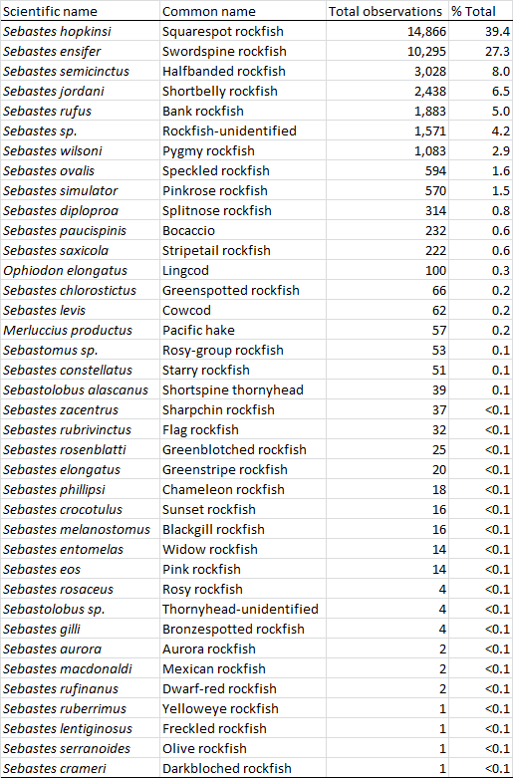

**Table 2.** Total area (sq. km) and sampling effort (total transect distance, km) by depth stratum and bank.

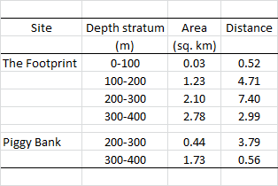

**Table 3.** Total abundance (number of individuals), biomass (kg), and bootstrapped coefficient of variation (CV) for each species across all depth strata and banks.

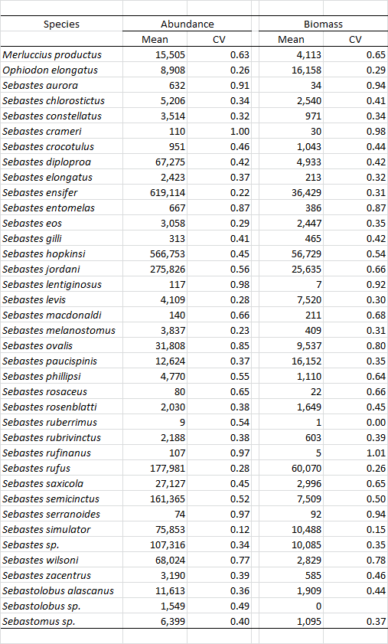

**Table 4.** A comparison of total length estimates for target rockfish species using parallel lasers and image analysis software (Image analysis) and using parallel lasers to assign fishes to 10 cm bins (Video analysis).

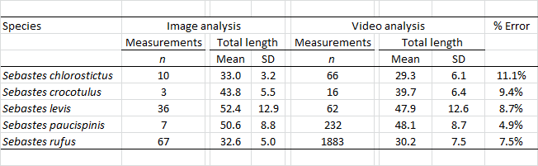

**Table 5.** A summary (% of all individuals) of observed fish reactions to the remotely operated vehicle (ROV). A reaction was defined as any movement or change in direction prior to the time when the analyst could make a positive identification.

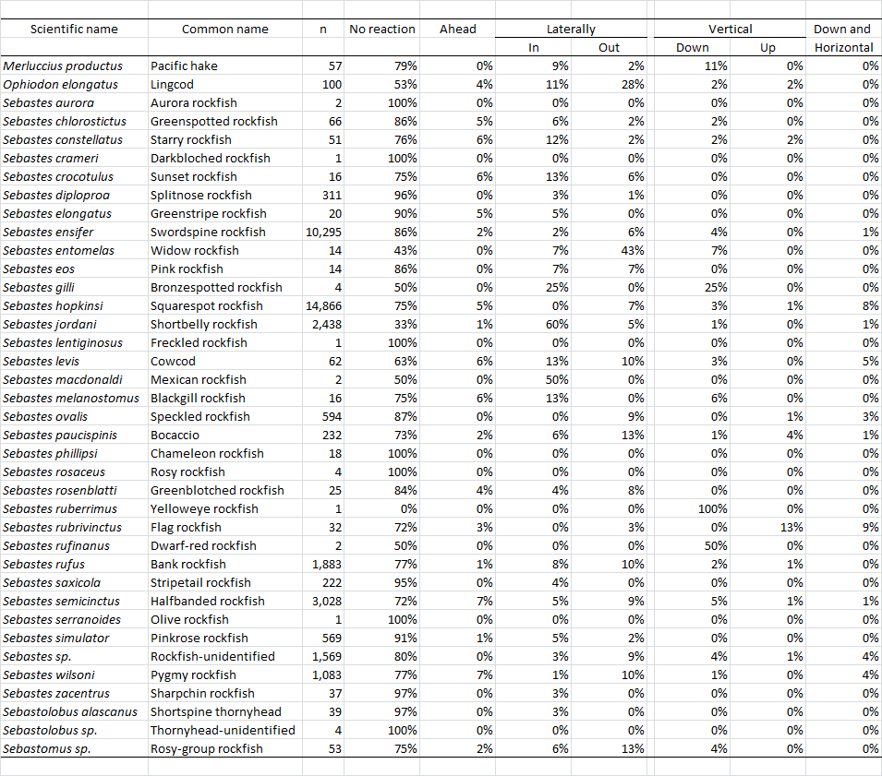

**Table 6.** Summary of species diversity by site and depth.

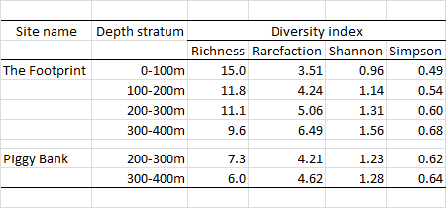

**Table 7.** Actual and optimal (Neyman 1934) allocation of sampling effort for several target species. Optimal-all allocates the total number of transects for the entire survey (i.e., at both banks; n = 37), and Optimal-site allocates only the number of transects actually conducted at each bank (n = 29 at The Footprint and n = 8 at Piggy Bank). Results for all species are presented in **Appendix 5**.

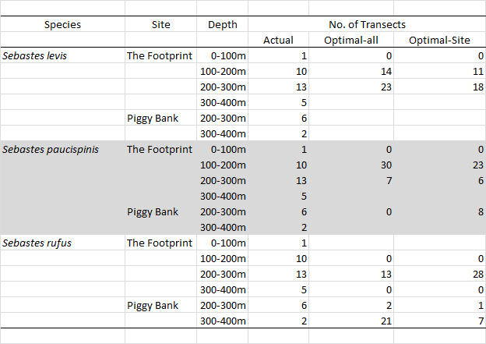

# Figures

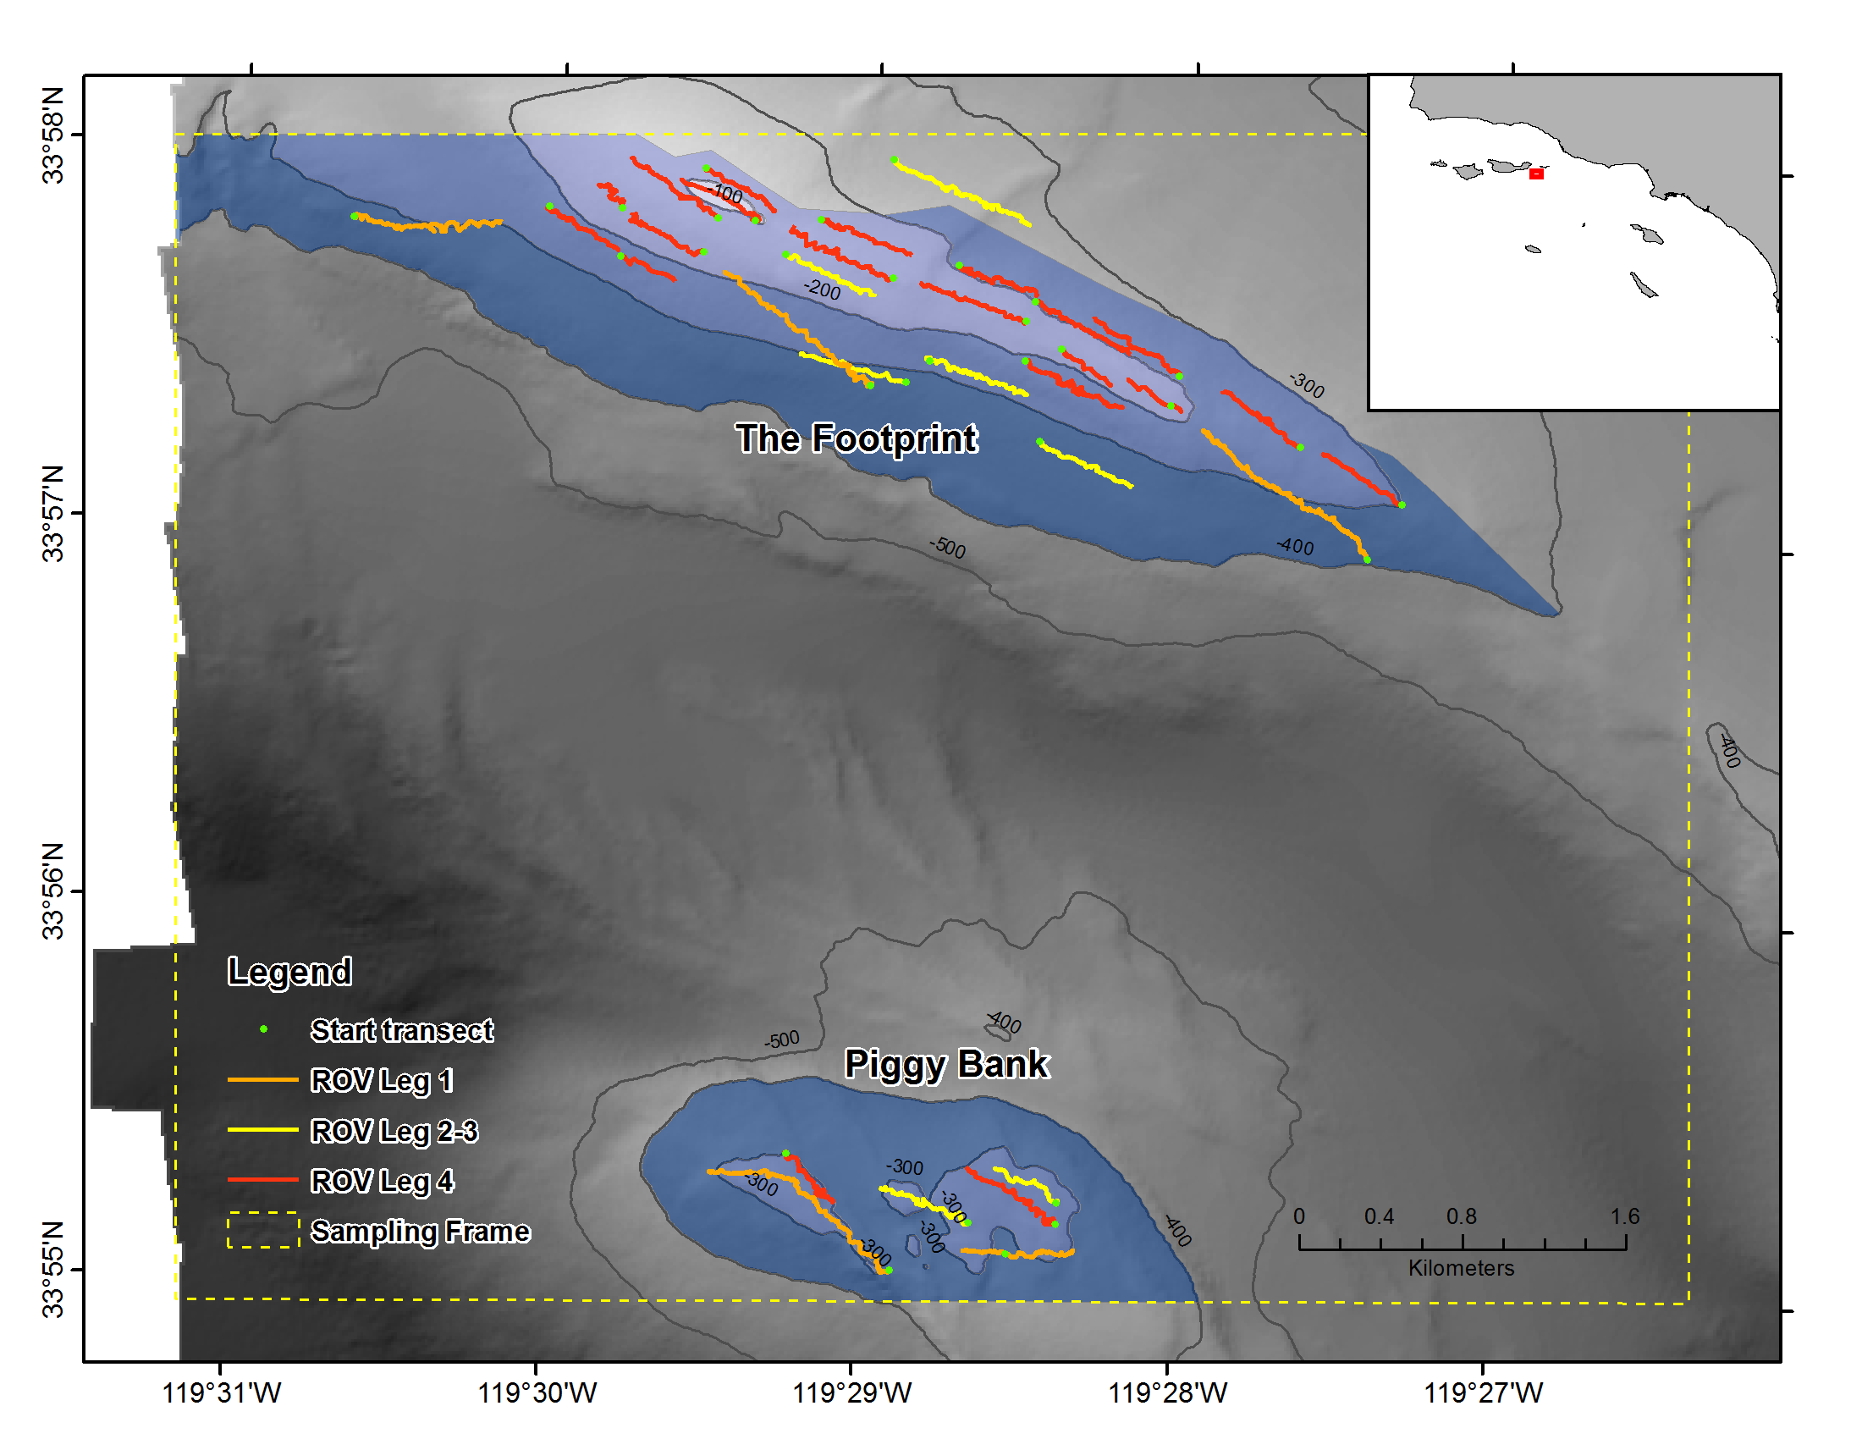

**Figure 1.** Map of the survey area indicating the extent of the sampling area, which includes The Footprint and Piggy Bank (dashed yellow box), the location of ROV transects (solid lines symbolized by cruise leg; green dots represent the starting location of each transect), and depth strata (blue polygons). The area within each polygon is in **Table 2**.

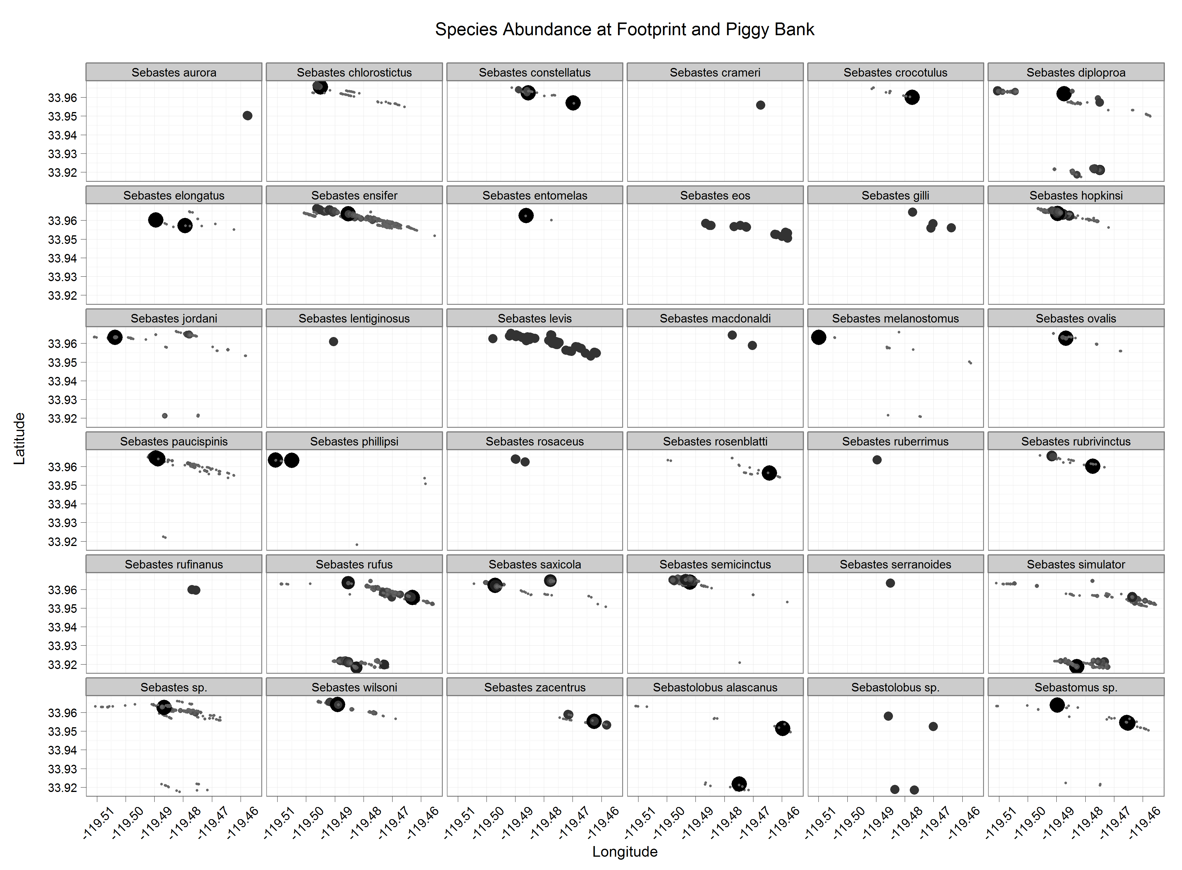

**Figure 2.** The distribution and relative abundance of each rockfish species over each of the banks. The radius of each point represents the number of individuals in each observation, and the size scale is independent within each panel.

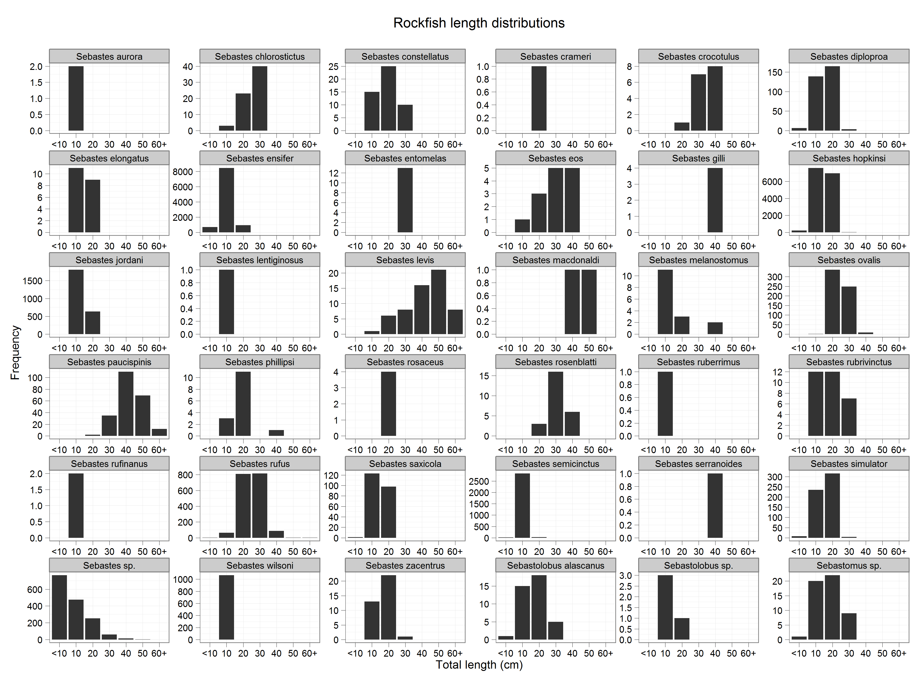

**Figure 3.** Total length ($TL$, cm) distributions for all rockfish species observed at both banks.

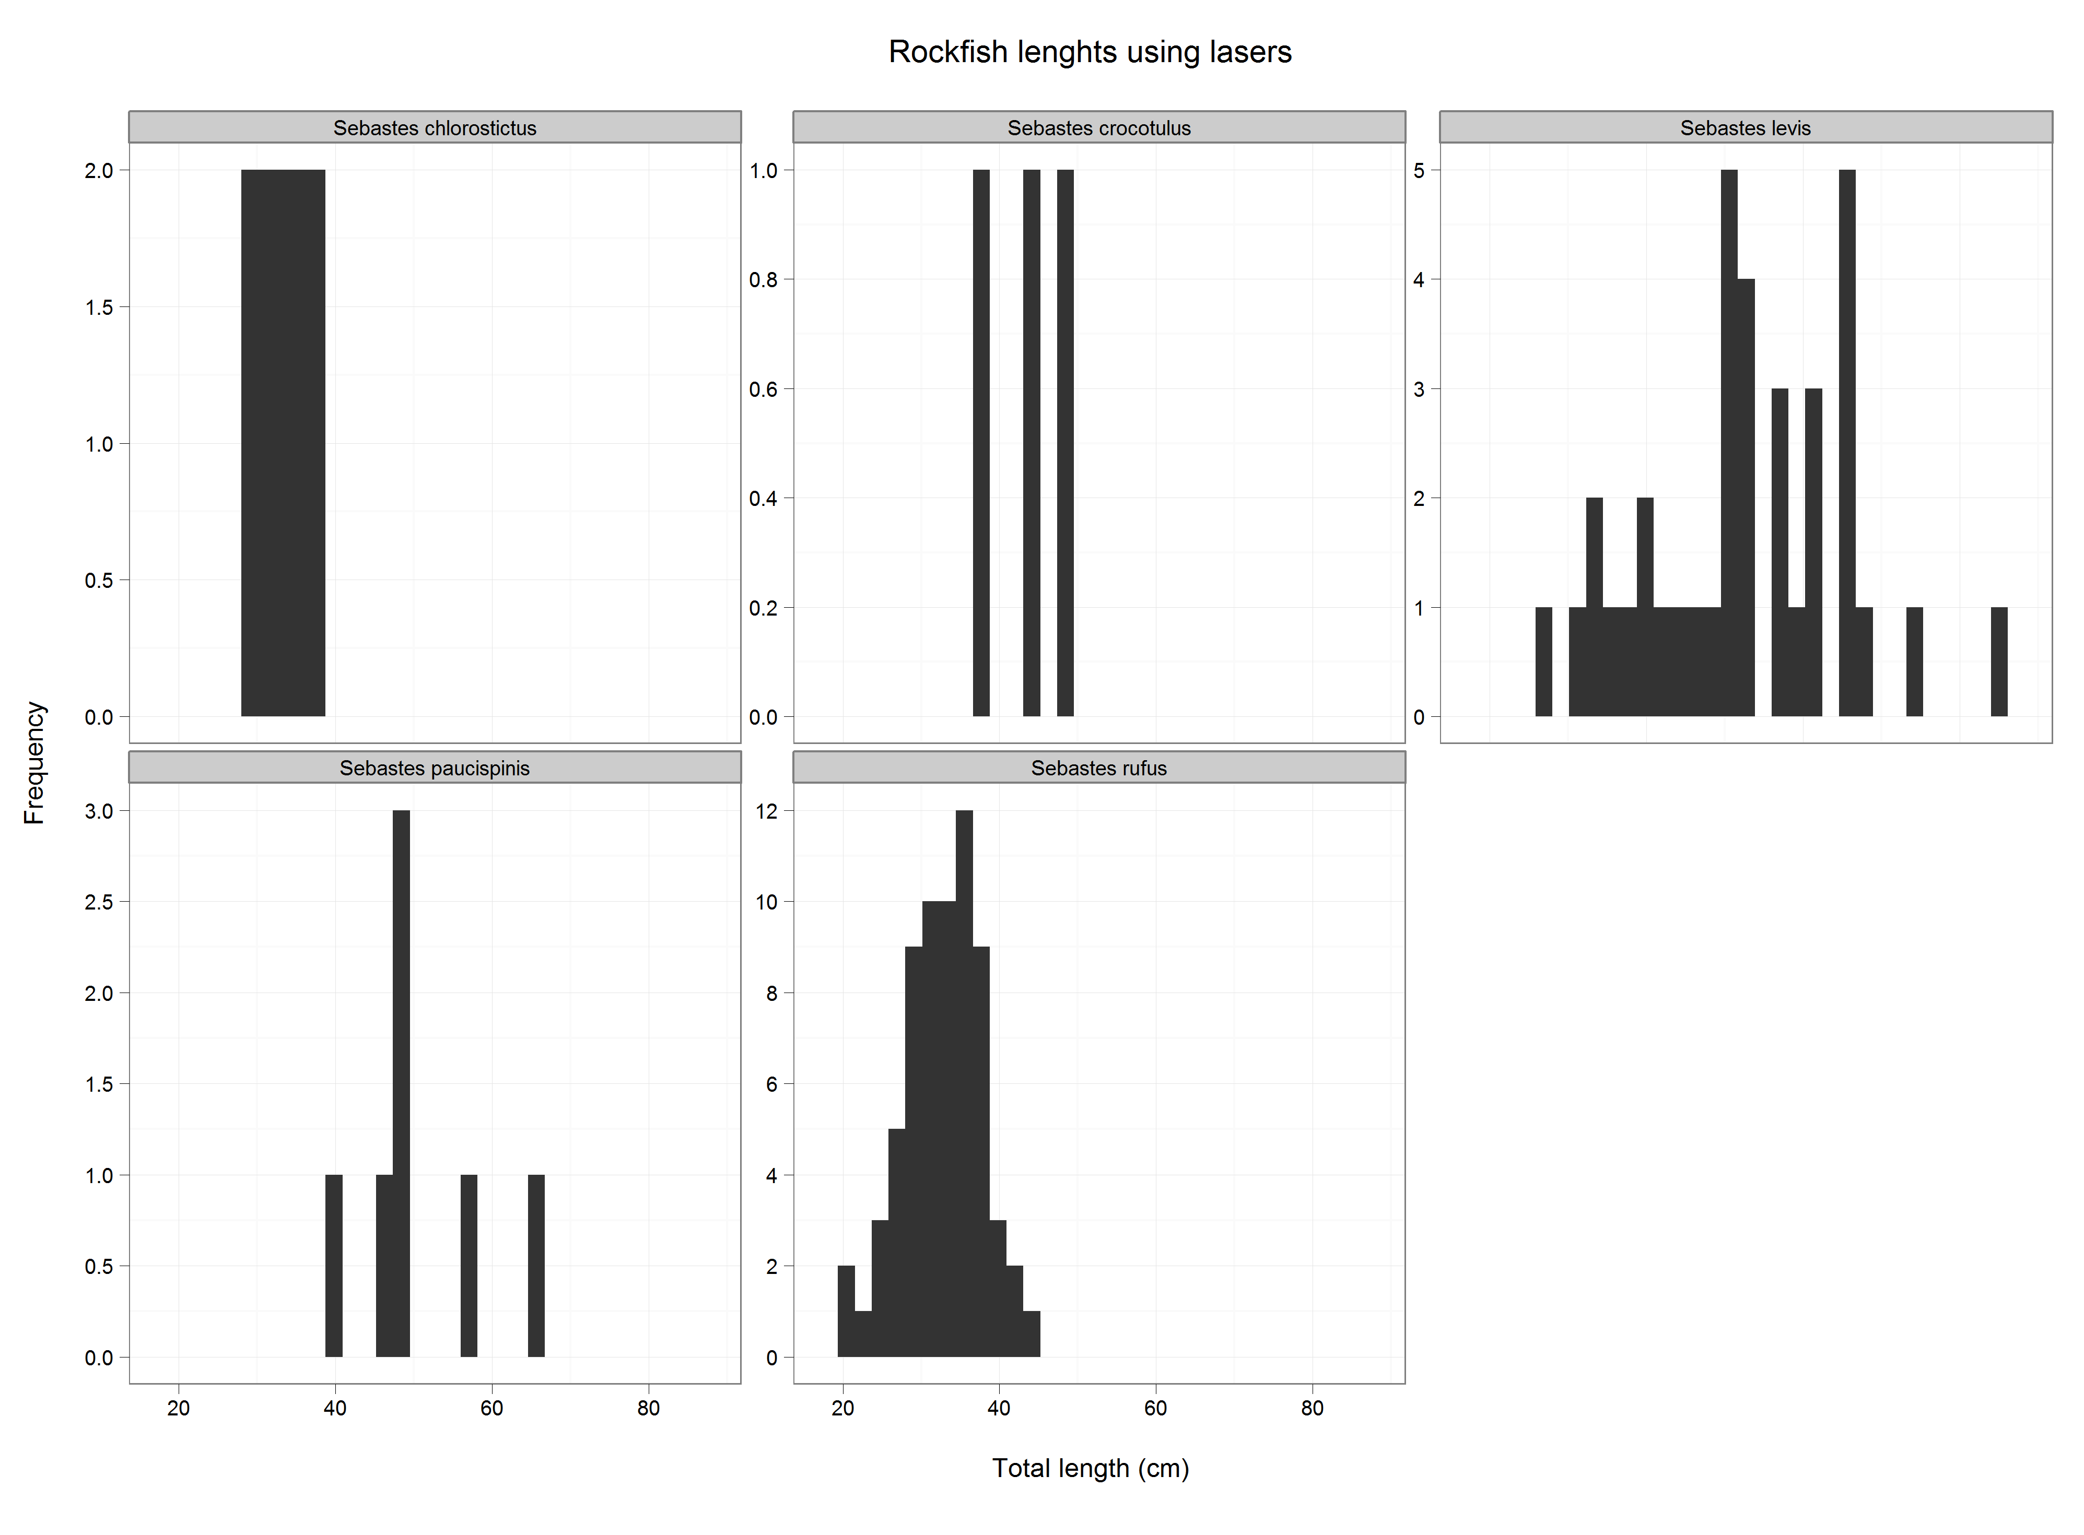

**Figure 4.** Total length ($TL$, cm) distributions for target rockfish species observed at both banks using parallel lasers and image analysis software.

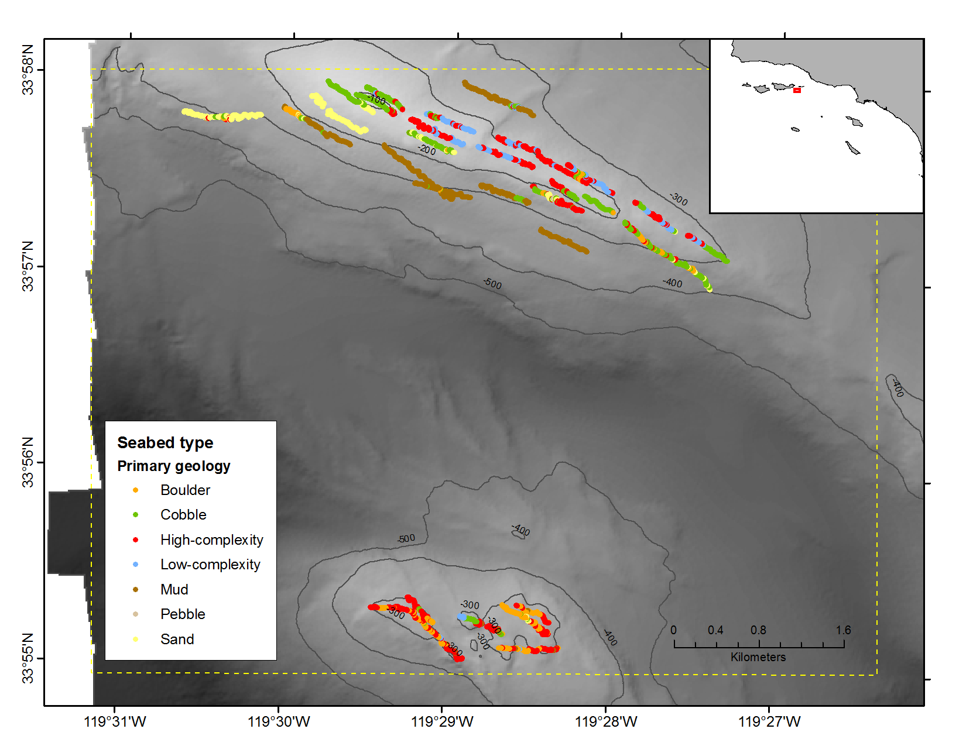

**Figure 5.** Observations of different seabed types along each transect. The color of each point corresponds to the primary (> 50% of the strip area) geological seabed type.

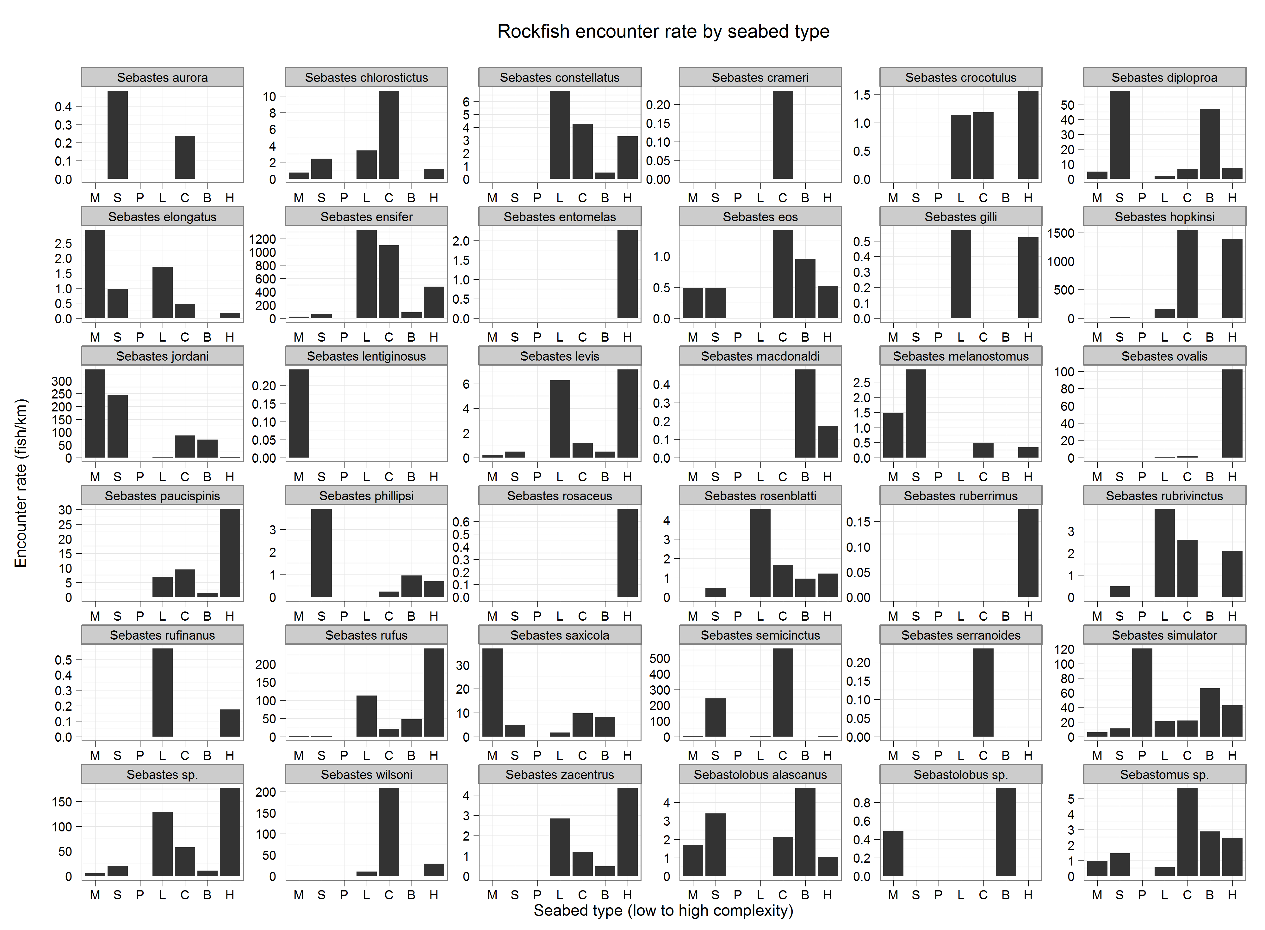

**Figure 6.** The encounter rate (number of fish per km) of each rockfish species by seabed type. The seabed types, which are described in detail in **Methods**, are arranged from low- to high-complexity along the x-axis.

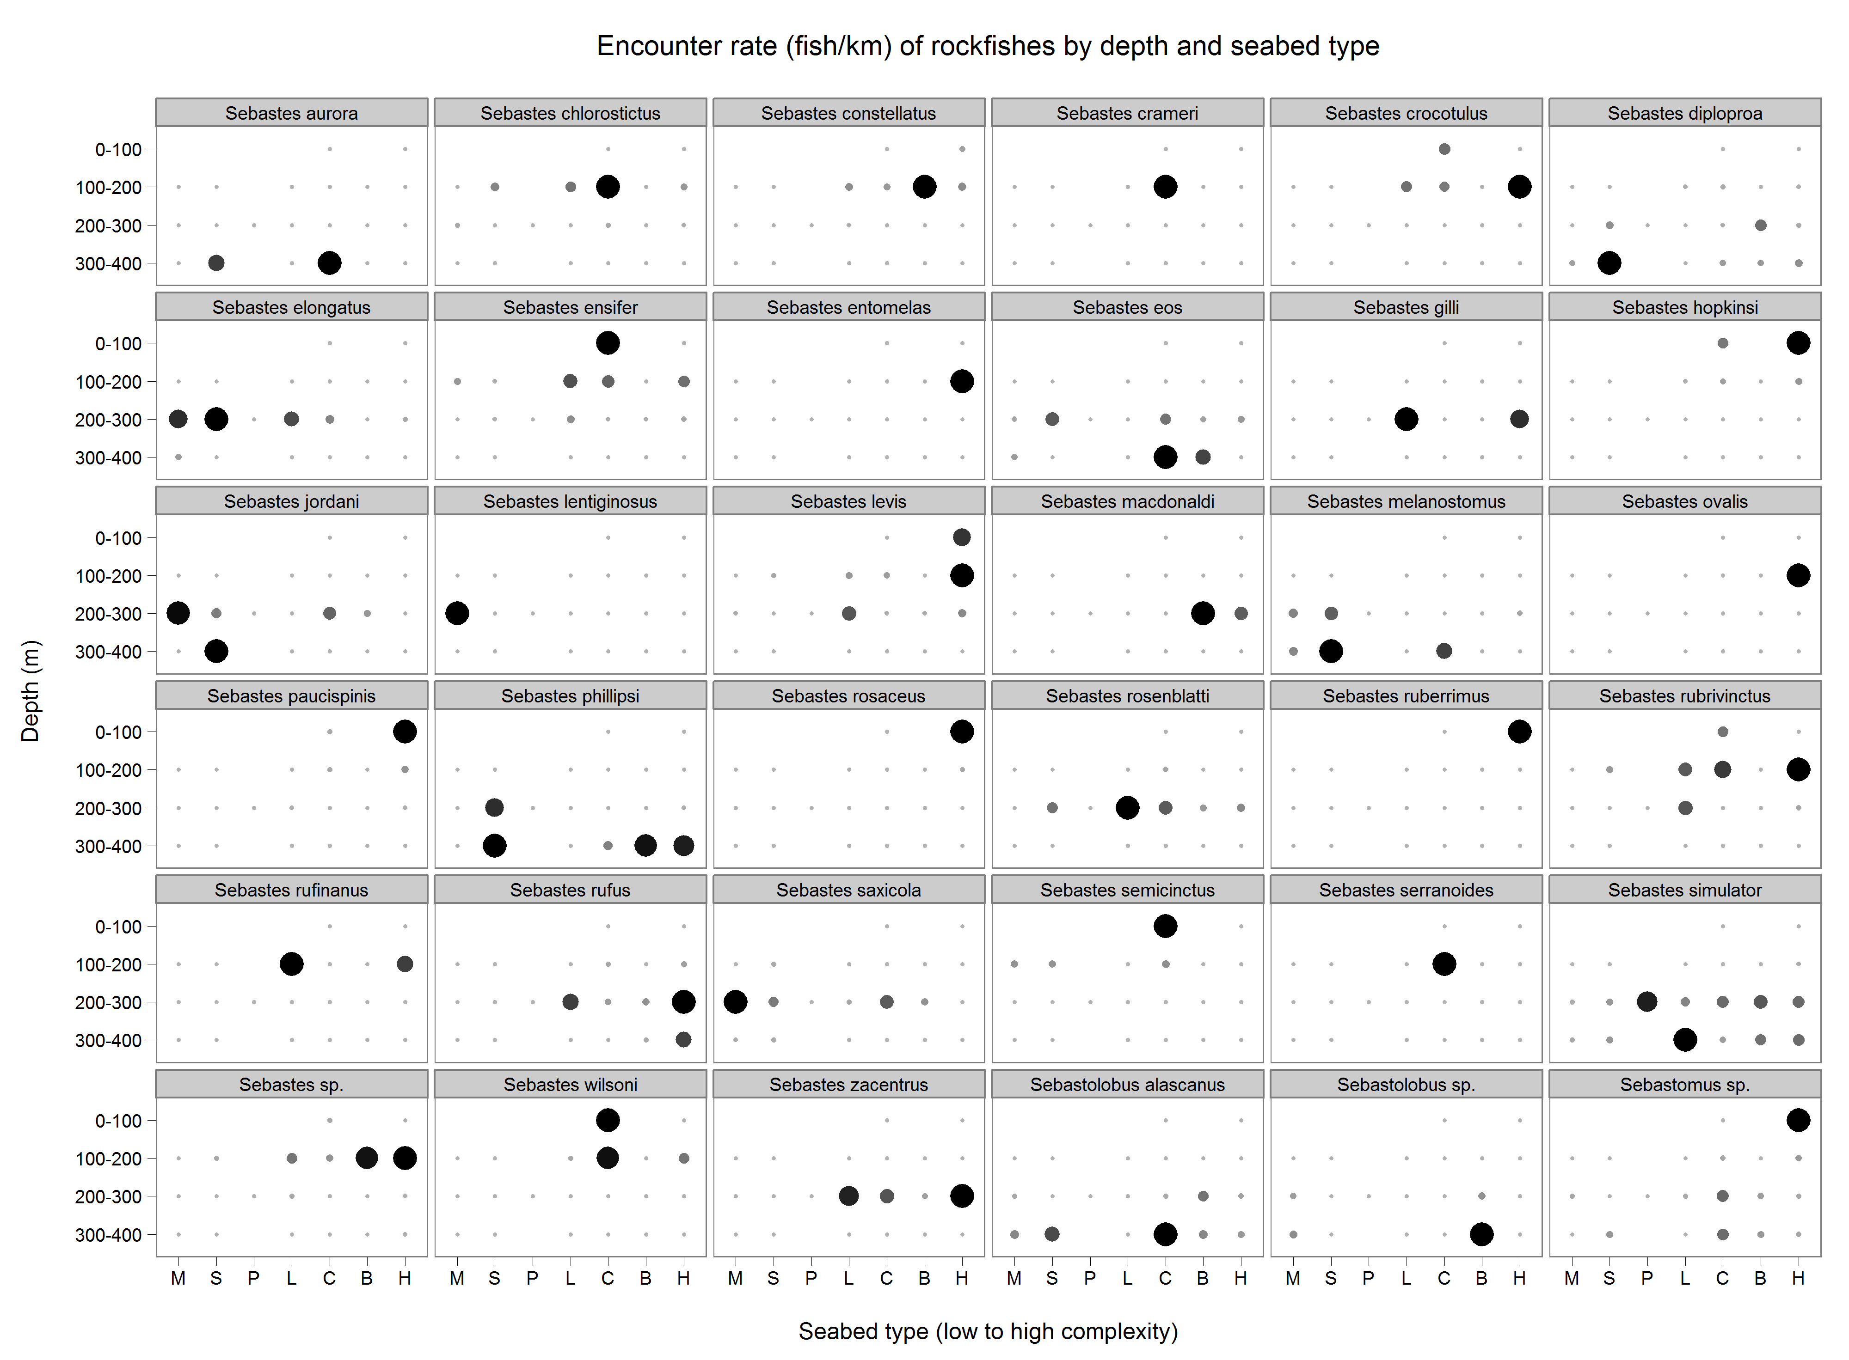

**Figure 7.** The encounter rate (number of fish by km) of each rockfish species by seabed type and depth stratum. The darkness and radius of each point are proportional to the encounter rate within each depth-seabed type combination; and the size scale is independent within each panel. The seabed types, which are described in detail in **Methods**, are arranged from low- to high-complexity along the x-axis.

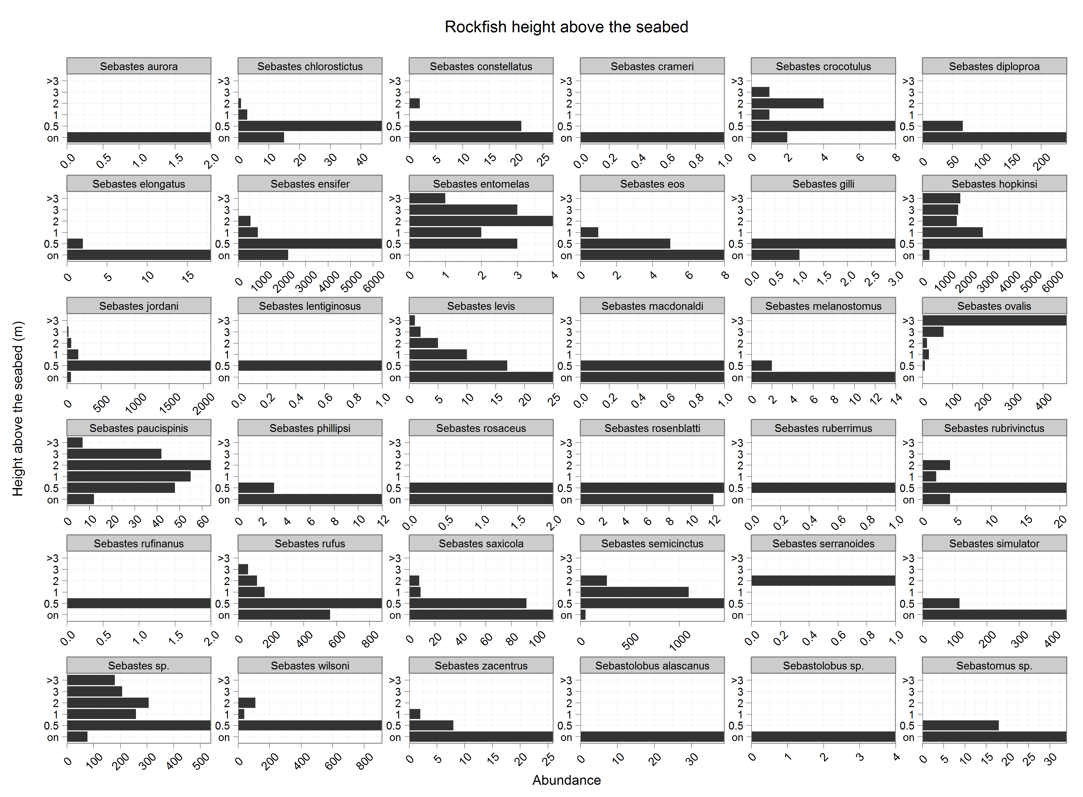

**Figure 8.** The vertical distribution of all rockfishes (height-above-the-seabed) observed during the study. The observations are not adjusted relative to the volume searched within each vertical depth stratum.

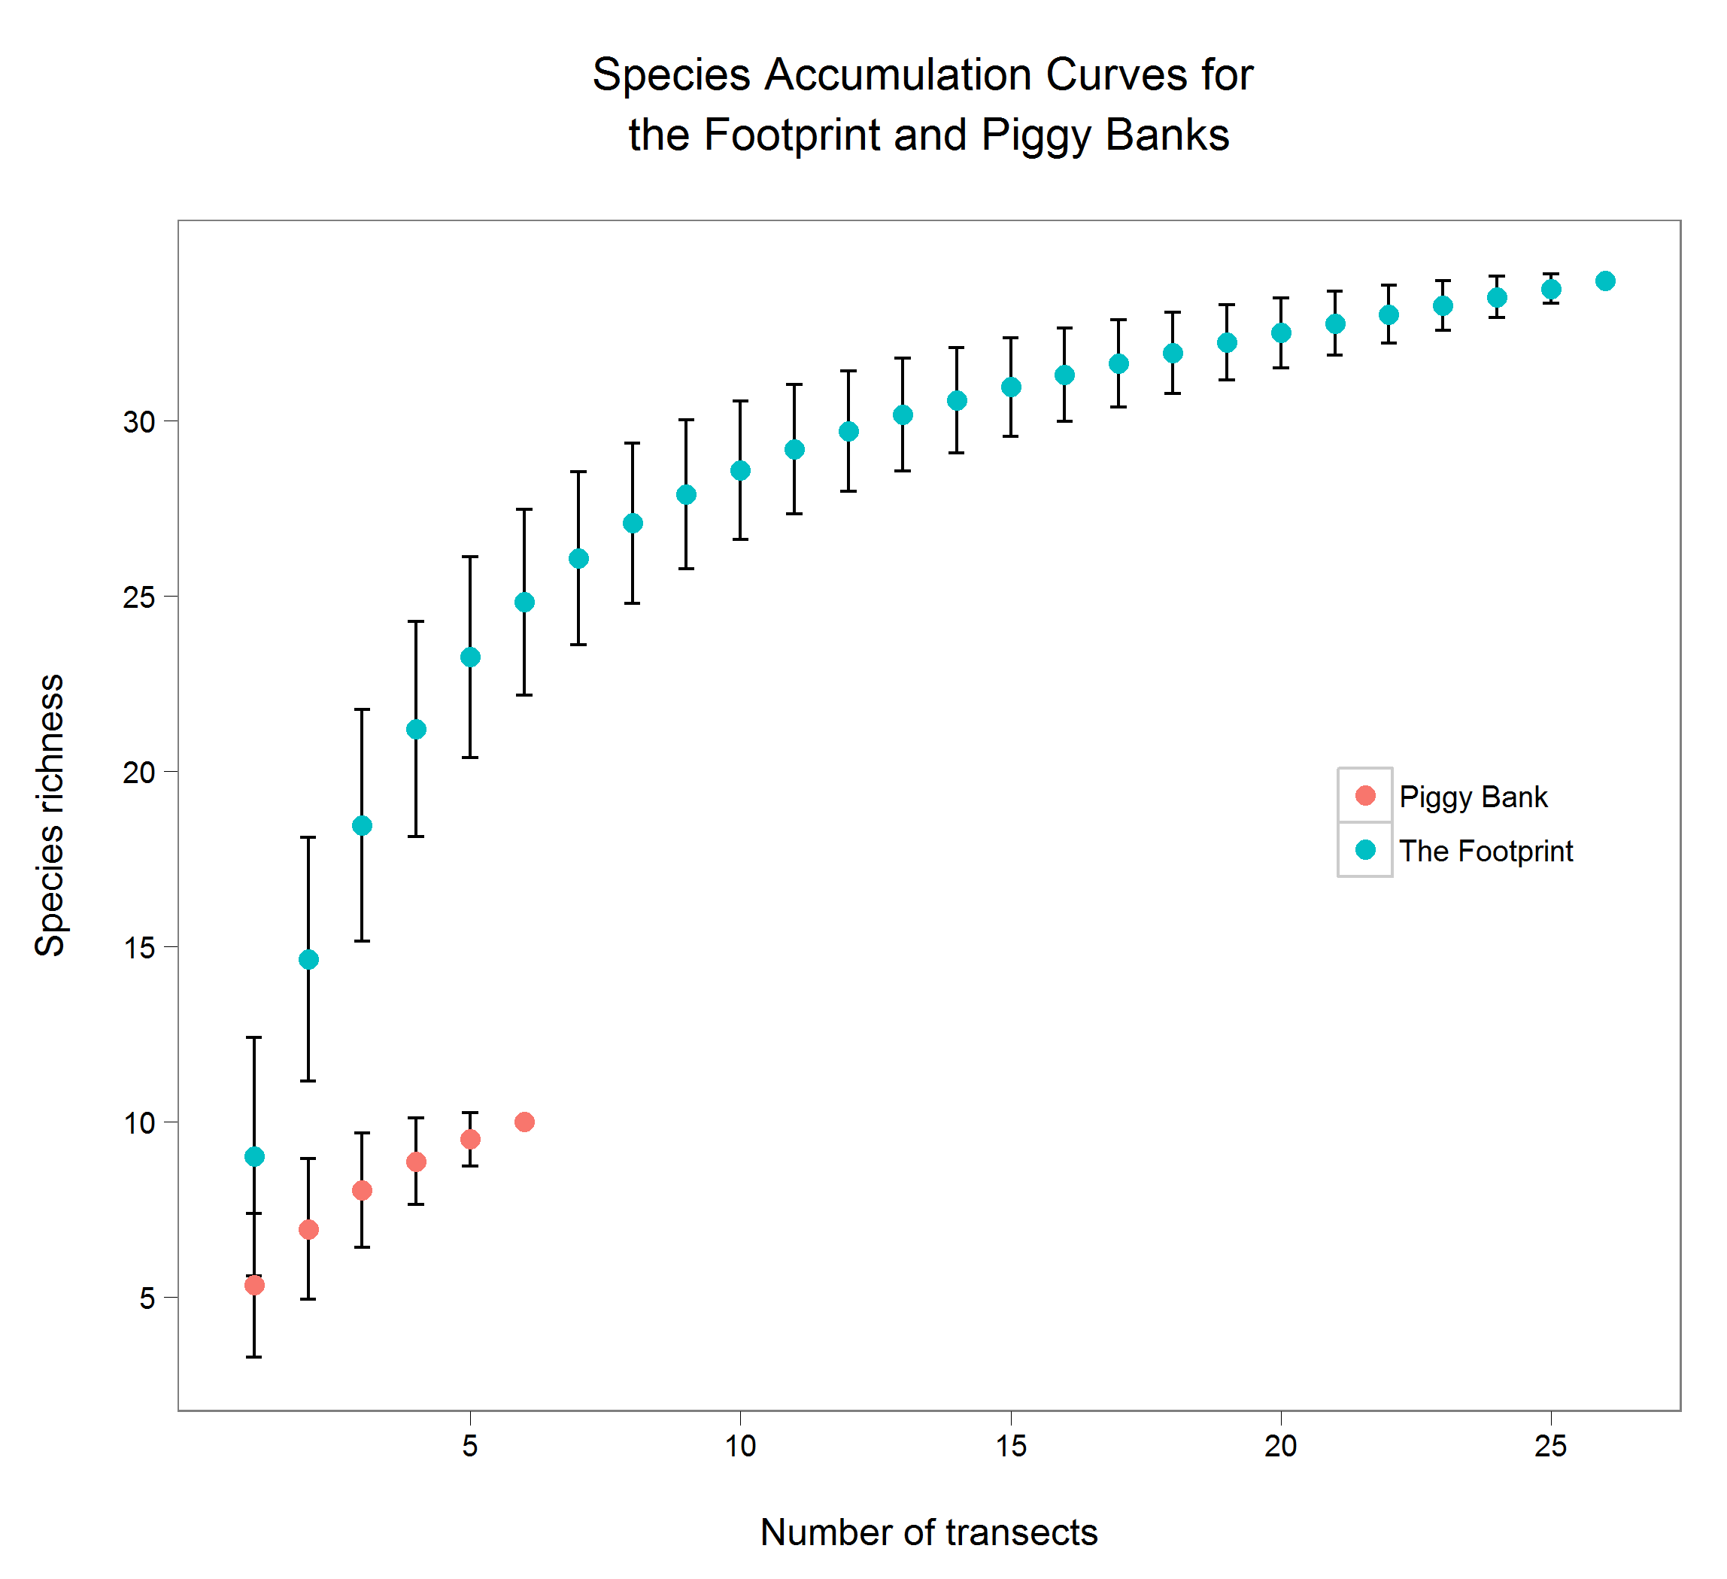

**Figure 9.** Species accumulation (rarefaction) curves for The Footprint and Piggy Bank. Error bars represent the standard deviation in the expected number of species (or species richness).

# Appendices

**Appendix 1.** Coefficients used to compute biomass (g, *B*) from total length ($TL$, cm)*.* When $TL/W$ relationships were unavailable, substitutions were made from closely related species as described in Hyde and Vetter (2007, 2008) (see Comment field).

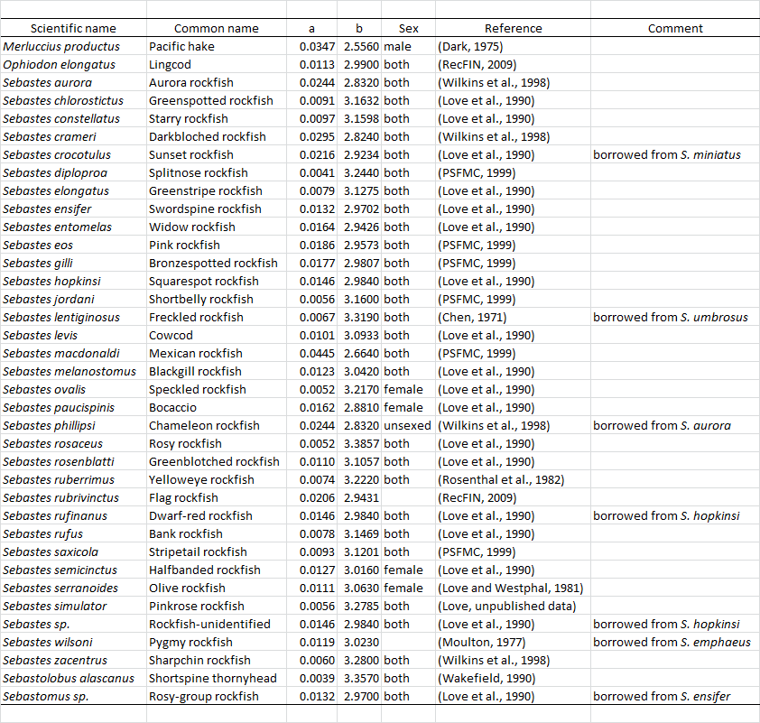

**Appendix 2.** Strip width estimates from each transect measured using photogrammetric software (3Beam, Kocak et al. 2002).

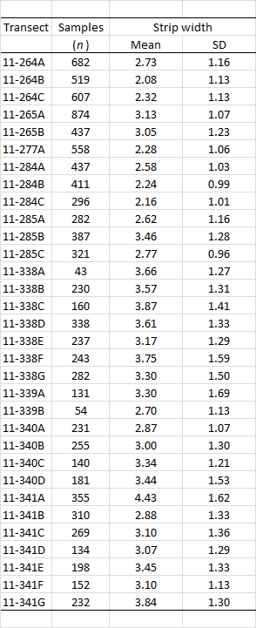

**Appendix 3.** Bootstrap estimates of abundance and biomass for all species within each bank and depth stratum.

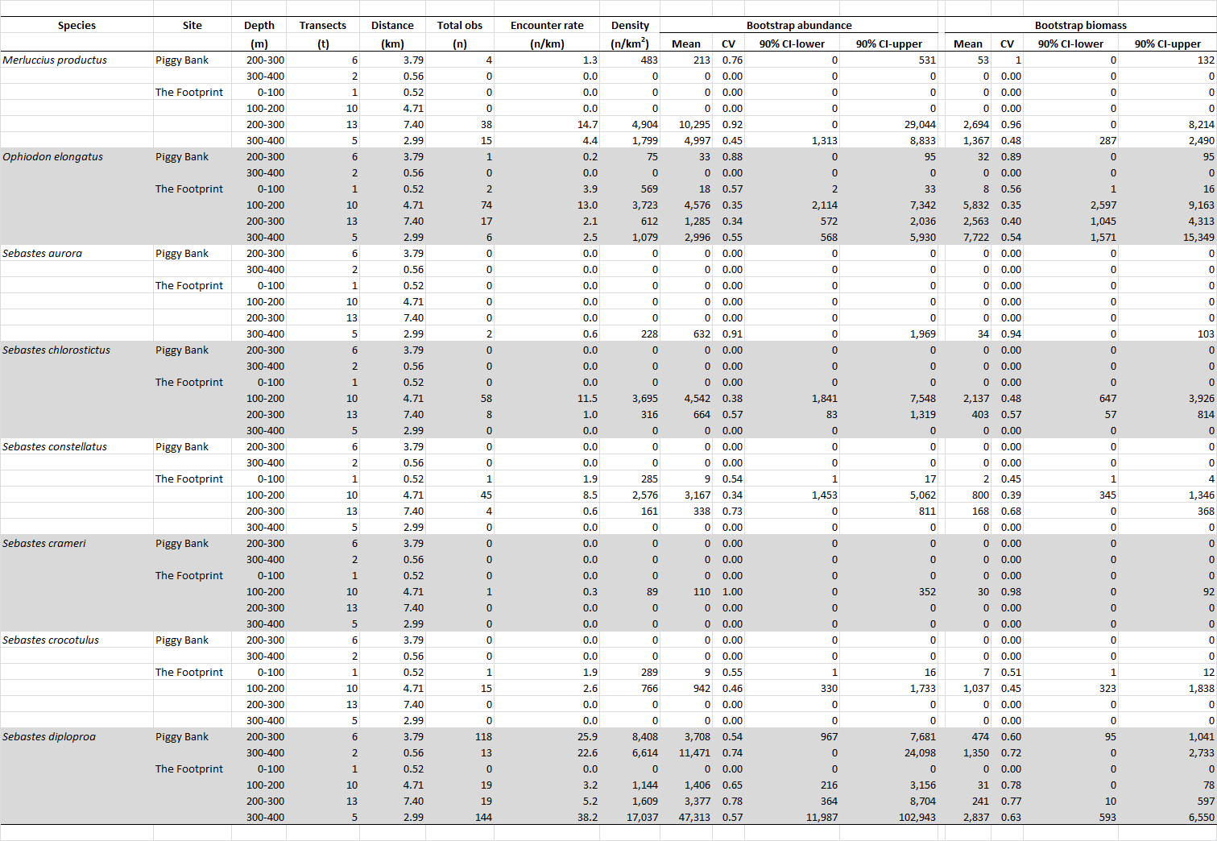

**Appendix 3 (cont.).** Bootstrap estimates of abundance and biomass for all species within each bank and depth stratum.

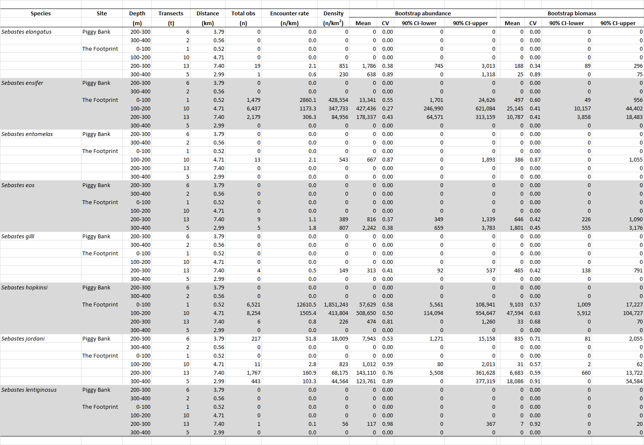

**Appendix 3 (cont.).** Bootstrap estimates of abundance and biomass for all species within each bank and depth stratum.

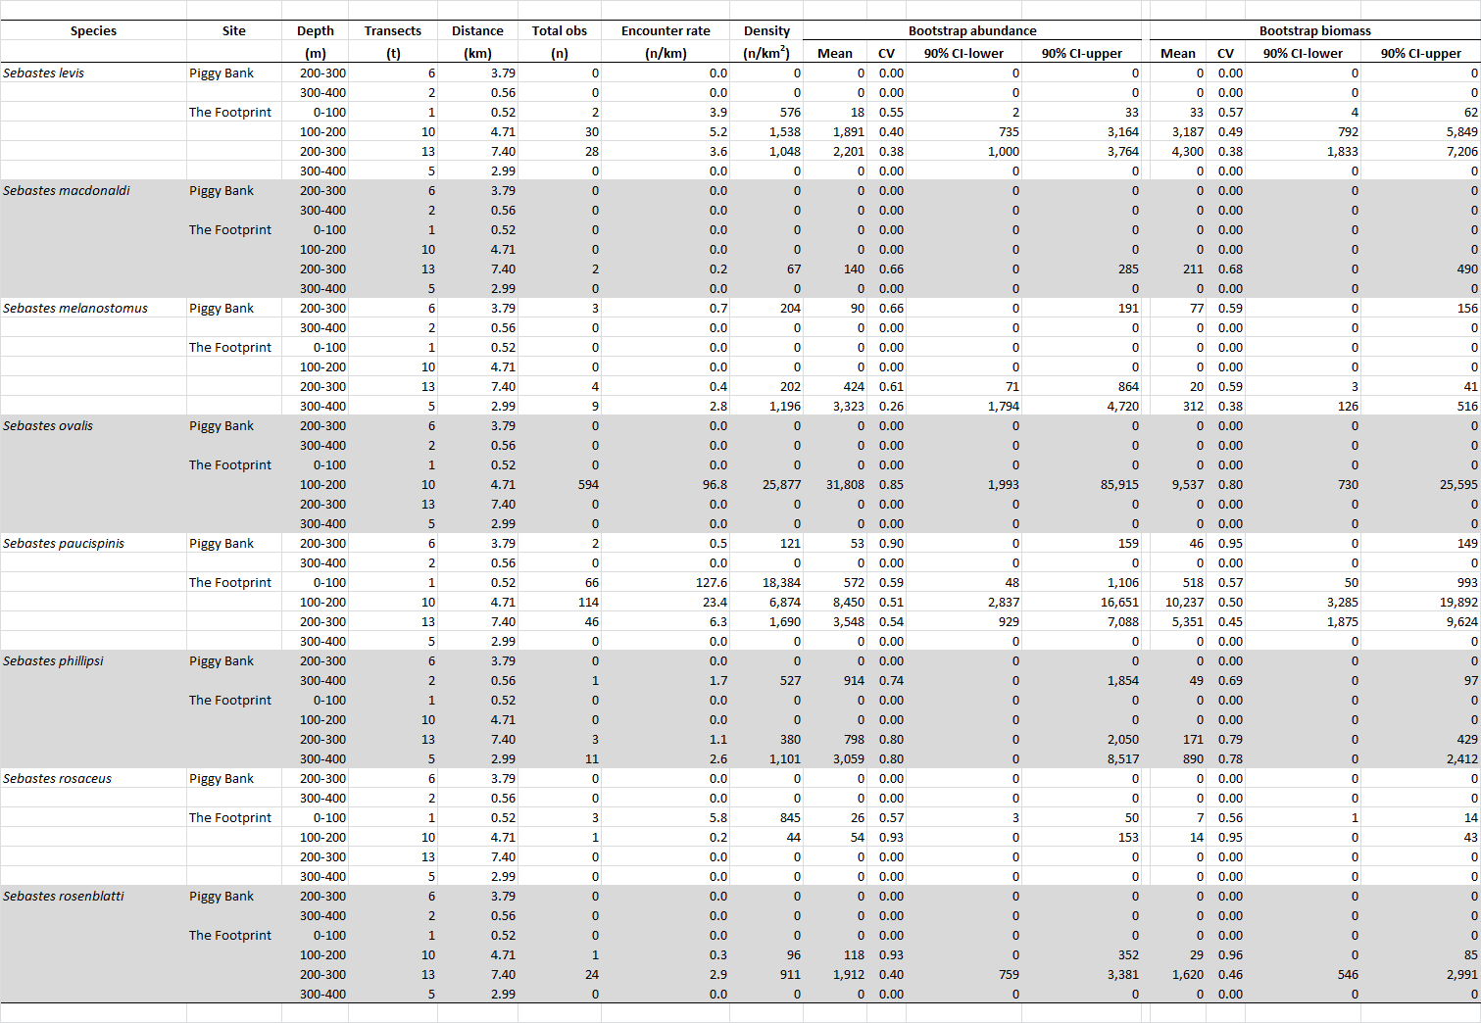

**Appendix 3 (cont.).** Bootstrap estimates of abundance and biomass for all species within each bank and depth stratum.

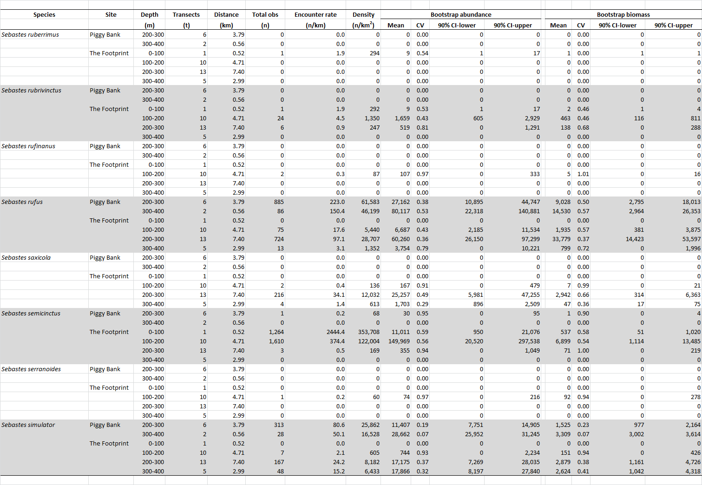

**Appendix 3 (cont.).** Bootstrap estimates of abundance and biomass for all species within each bank and depth stratum.

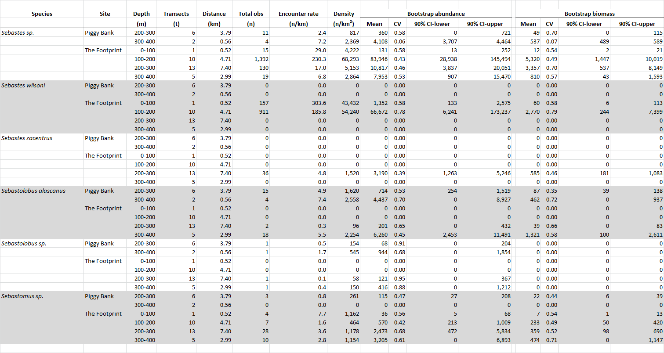

**Appendix 4.** Diversity statistics for each transect, arranged by bank and depth stratum.

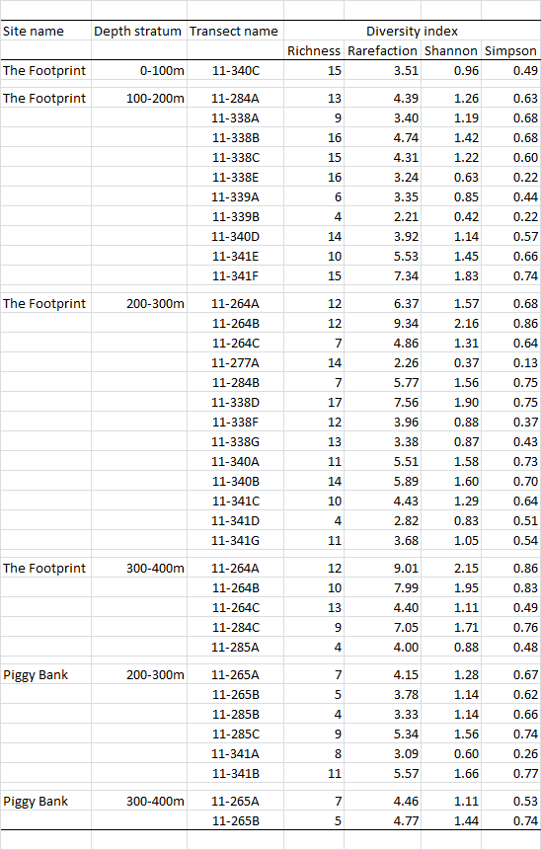

**Appendix 5.** Optimal sample allocation following Neyman (1934).

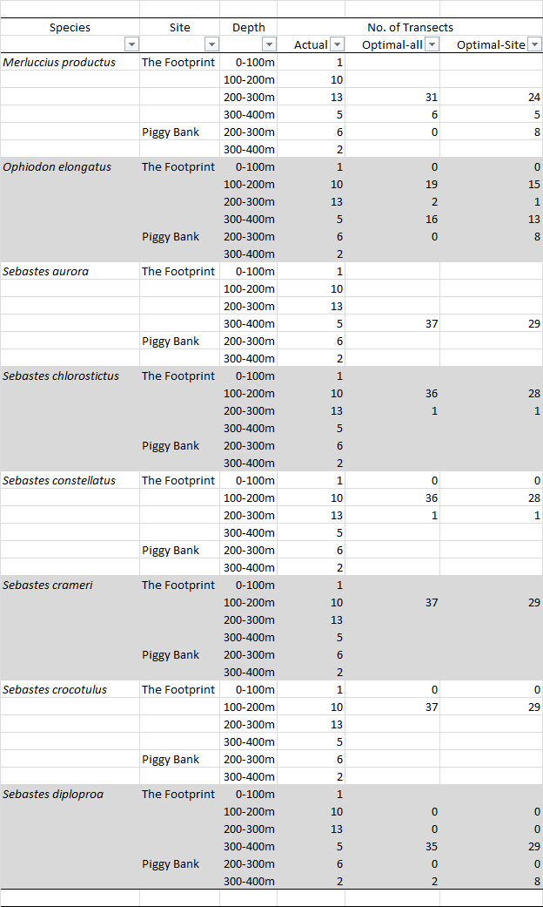

**Appendix 5 (cont.).** Optimal sample allocation following Neyman (1934).

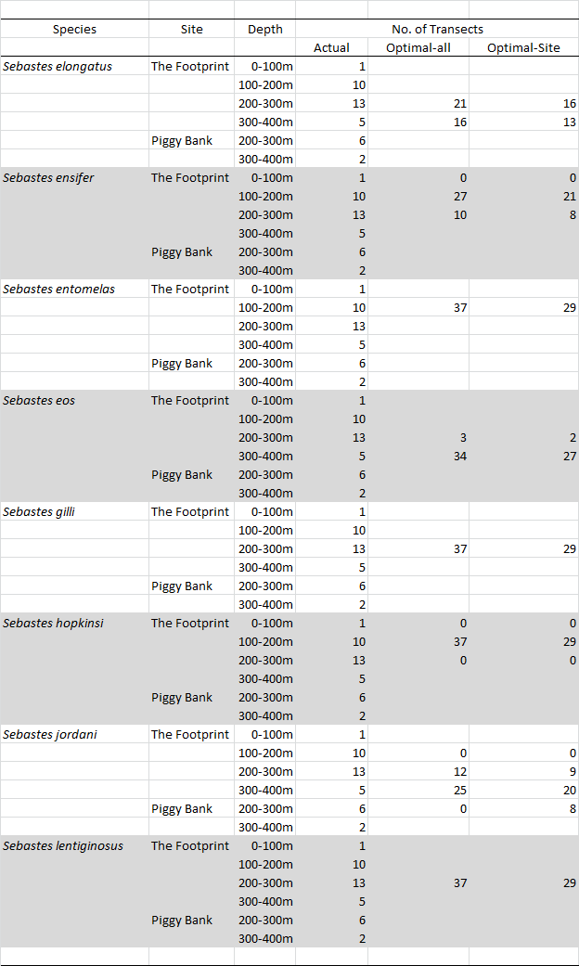

**Appendix 5 (cont.).** Optimal sample allocation following Neyman (1934).

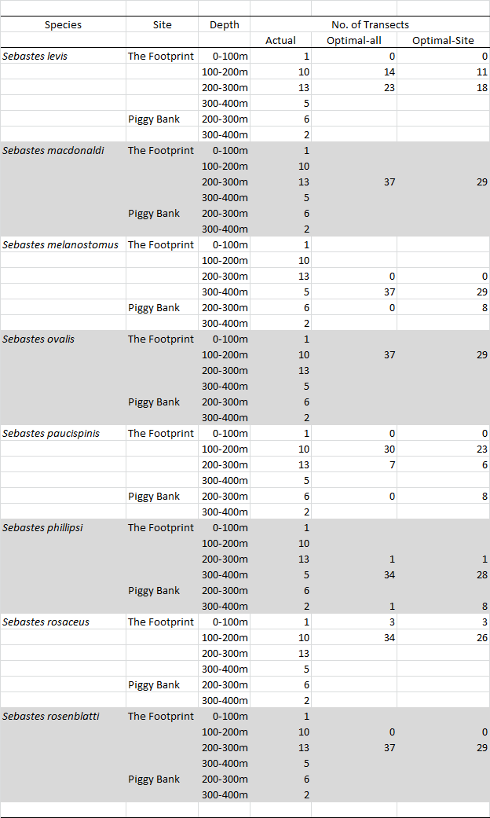

**Appendix 5 (cont.).** Optimal sample allocation following Neyman (1934).

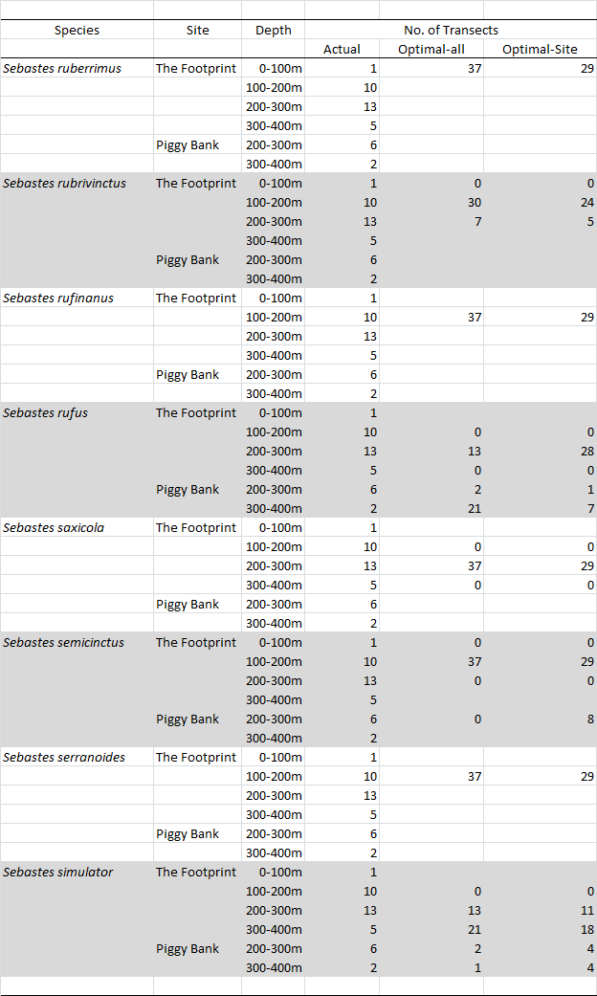

**Appendix 5 (cont.).** Optimal sample allocation following Neyman (1934).

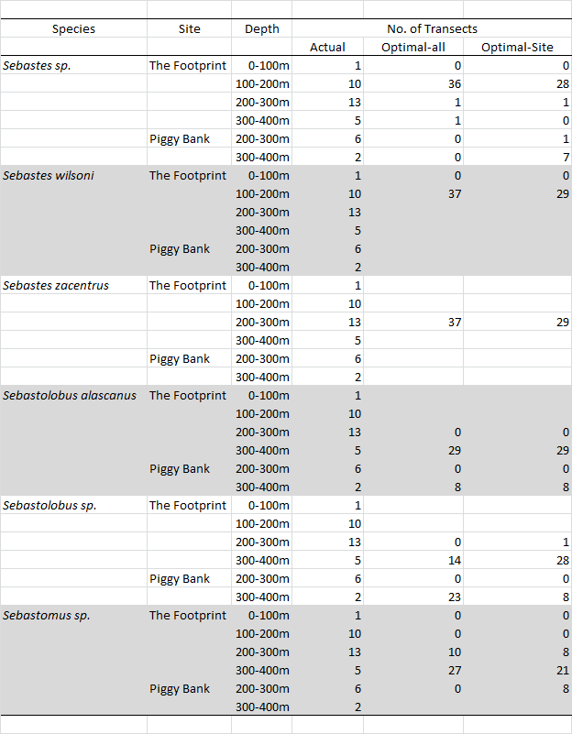

**RECENT TECHNICAL MEMORANDUMS**

SWFSC Technical Memorandums are accessible online at the SWFSC web site (http://swfsc.noaa.gov).

Copies are also available from the National Technical Information Service, 5285 Port Royal Road,

Springfield, VA 22161 (http://www.ntis.gov). Recent issues of NOAA Technical Memorandums from the

NMFS Southwest Fisheries Science Center are listed below: